NEWSLETTER December 2023

Peter Dawson Lodge
Box 750 Vulcan, AB T0L 2B0 614 1st Street North
403-485-5422

Editor’s Desk

Hello Residents, Families and Friends!
Can you believe we are entering the hustle and bustle of the holiday season? It seems like it was just yesterday when we were welcoming 2023 and now it is almost time to say hello to 2024. Time does fly when you’re having fun!
I hope that you’ll have the opportunity to enjoy at least a few festive events that we have planned this month. You’ll find a lot of Christmas activities over the next month. We’ll also have our “normal” programming throughout the month if you need a break from the twinkle lights and sugar cookies.
As we look forward to 2024, I want to express my gratitude for the opportunity to be part of the PDL family. Wishing all of you a Merry Christmas and all the best in 2024.
Sherry
Director of Resident Care
Quote of the Day
Christmas waves a magic wand over this world, and behold, everything is softer and more beautiful.
– Norman Vincent Peale
December Trivia

Babies born the last month of the year are more likely to live the longest!

Zodiac signs: Sagittarius & Capricorn
Birthstone: Turquoise
Flower: Holly

What We’ve Been Up To…
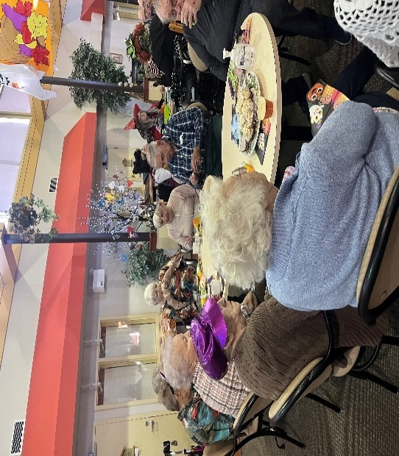
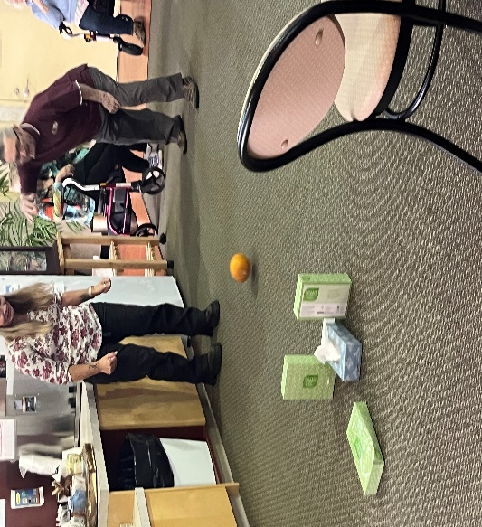
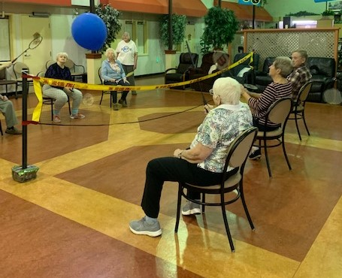
We had visitors that played pumpkin bowling with our residents. Hopefully no squished pumpkins.
Balloon Badminton is a favorite at the lodge. Keeps us on our toes as we keep the balloon in the air.
Halloween Happy Hour! We had witches brew and snacks and lots and lots of laughs. And a few unexpected visitors as well. 😊
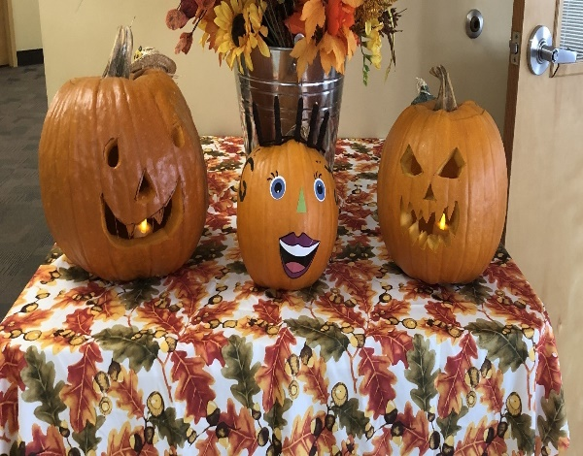
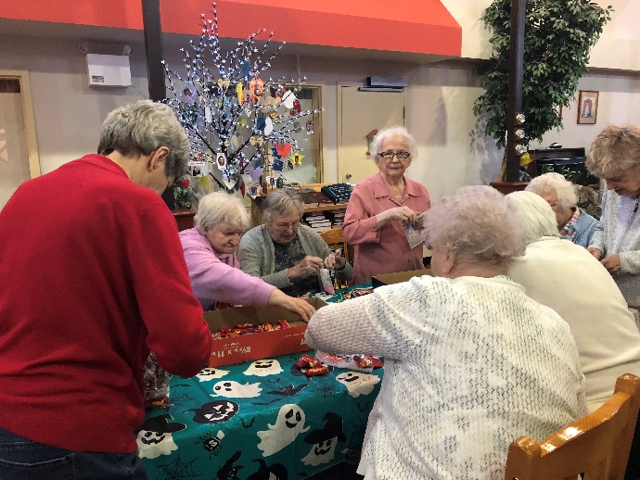
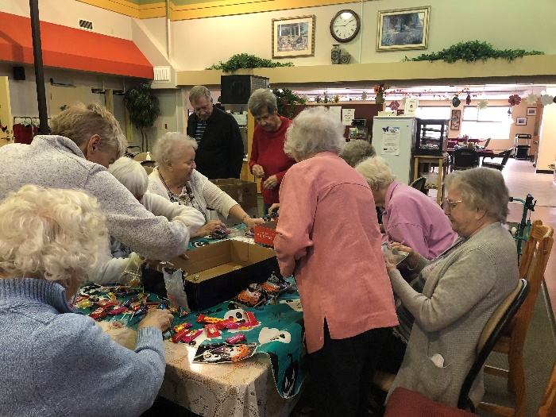
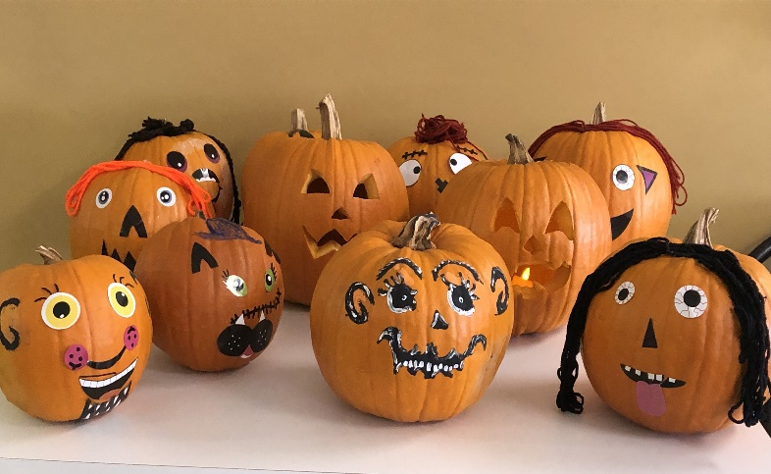
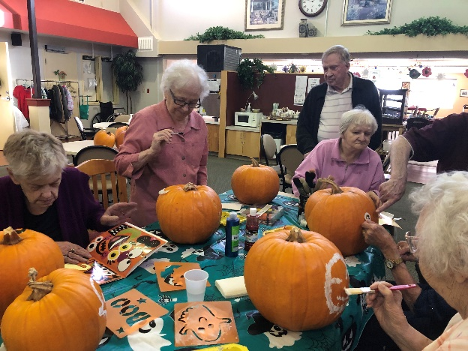

Halloween
Preparations
Residents decorated pumpkins for the 1St Annual Pumpkin Walk in Vulcan. Pumpkins were donated by Market Street. Credit Union delivered the pumpkins and picked them up after decorating was complete. Our residents had a great time exploring their imaginations and using their talent. Thankyou Everyone!!

Residents filling Candy bags for Trick or Treaters
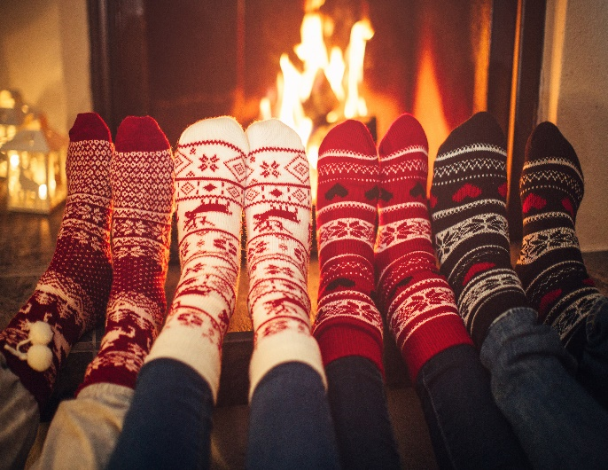
Regular Events

ents

Resident’s Meeting
Tuesday, December 5th 10:30 am in the Atrium
Pool Noodle Exercises
Tuesdays, Wednesdays, Thursdays, Saturdays &
Sundays in the Atrium
Balloon Badminton
Tuesdays & Thursdays in the Atrium
Courtesy Car
Special Days in December
1st Summer (S. Hem)
4th Cookie Day (US)
5th Volunteer Day
6th St. Nicholas Day
7th Hanukkah Begins
18th Paul Klee’s Birthday
21st Winter (N. Hem)
25th Christmas
26th Boxing Day
26th Kwanzaa
31st New Year’s Eve

Wednesdays

Hairdresser
Thursdays

Games
Daily at 3pm except Saturdays in the Atrium
Everyone is welcome to join us for these daily events.

Up Coming Events
Christmas Decorating and Christmas Cards
First week in December in the afternoons

Ice Cream
Friday, December 8th 3:00 pm

Staff/Resident Christmas Party
Wednesday, December 13th 5:00pm

New Year’s Eve Party
Friday, December 29th 2:30pm
 | · December 2023 ·
∙ Sunday ∙ | ∙ Monday ∙ | ∙ Tuesday ∙ | ∙Wednesday ∙ | ∙ Thursday ∙ | ∙ Friday ∙ | ∙ Saturday ∙
10 DAYS OF CHRISTMAS DECEMBER 11 -22 |  |  |  |  | 1  9:00 Floor Curling  10:30 Bible Study  3:00 Kerplunk  6:30 Social Hour  Sole Worthy Foot Care | 2  10:30 Pool Noodle  Exercises
3  10:30 Pool Noodle  Exercises  3:00 Dice  Game | 4  9:00 Bean Bag Tournament $2  2:00 Christmas Tree Decorating  6:30 Good News | 5  9:00 Balloon  Badminton  10:30 Resident’s Meeting  3:00 Music with Diane | 6  Courtesy Car  9:00 Roller Ball  10:30 Pool Noodle Exercises  3:00 Horse Races with Lionettes | 7  9:00 Balloon  Badminton  10:30 Pool Noodle Exercises  1:00 FCSS  2:00 Music with Howard’s Son’s  Happy Birthday Gloria! | 8  9:00 Soccer  10:30 Bible Study  2:00 Christmas Cards  6:30 Social Hour | 9  10:30 Pool Noodle  Exercises  Happy Birthday Deb!
10  10:30 Pool Noodle Exercises  3:00 Dice  Game | 11  9:30 Shuffleboard  Tournament $2  3:00 Chase the Ace  6:30 Good News | 12  9:00 Balloon  Badminton  10:30 Pool Noodle Exercises  3:00 Winter Hangman | 13  Courtesy Car  2:30 Congregational Church  5:00 Lodge Christmas Party | 14  9:00 Balloon  Badminton  10:30 Pool Noodle Exercises  1:00 FCSS  3:00 Music with Kelly  Happy Birthday Helen F! | 15  9:00 Floor Curling  10:30 Bible Study  3:00 Ice Cream  6:30 Social Hour  Sole Worthy Foot Care | 16  10:30 Pool Noodle  Exercises
17  10:30 Pool Noodle Exercises  3:00 Dice  Game | 18  9:30 Lomond School  1:00 FCSS  2:00 Christmas Cookies  6:30 Good News  Happy Birthday Susan K! | 19  3:00 Christmas Bingo  6:30 Christmas Light Tour | 20  Courtesy Car  9:00 Roller Ball  10:30 Pool Noodle Exercises  2:00 CCHS Band | 21  9:00 Balloon  Badminton  10:30 Pool Noodle Exercises  1:00 Reader’s Build  3:00 Snow Ball Toss  Residents Choice Dinner | 22  9:00 Soccer  10:30 Bible Study  3:00 Christmas Happy Hour  6:30 Social Hour  Ugly Sweater Day! | 23  10:30 Pool Noodle  Exercises
24  10:30 Pool Noodle Exercises  3:00 Dice | 25  Christmas Day  9:00 Shuffle Board  3:00 Chase the Ace | 26  Boxing Day  9:00 Balloon Badminton  10:30 Pool Noodle Exercises  3:00 31 Card Game | 27  Courtesy Car  9:00 Roller Ball  10:30 Pool Noodle Exercise  3:00 Uno | 28  9:00 Balloon Badminton  10:30 Pool Noodle Exercises  3:00 Memory Game | 29  9:00 Soccer  10:30 Bible Study  3:00 Card Bingo  6:30 Social Hour  Happy Birthday Mary! | 30  10:30 Pool Noodle  Exercises
31
10:30 Pool Noodle Exercises
3:00 Dice Game

December Birthdays

In December, we celebrate birthdays with:

- CAO Gloria December 7th
- Housekeeping Deb December 9th
- Resident Helen F December 14th
- Kitchen Susan K December 18th
- Resident Mary December 29th

Please join us in the recreation room on the first Sunday
in December to celebrate!

Sagittarius (Nov 23 - Dec 21)
Sagittarians are artistic, loyal, sophisticated, independent, and kind!

Capricorn (Dec 22 – Jan 19)
Capricorns are responsible, disciplined and have good managers
Can you finish these Christmas carol lyrics?
Oh, the weather outside is _____________________!
Since we’ve no place to go, let it _________________.
With a corncob pipe and a button ________________.
Dashing through the snow, in a __________________.
I saw Mommy kissing __________________________.
The holly and the ivy, when they are both __________.
City sidewalks, busy sidewalks, dressed in _________.
Chestnuts roasting on _________________________.
Up on the rooftop reindeer _____________________.
What is your favorite holiday movie?
There’s nothing like grabbing favorite snacks, settling in under a cozy blanket, and turning on a favorite holiday movie. According to Entertainment Weekly, the most favorite holiday movie is It’s a Wonderful Life, followed by A Christmas Story, and A Charlie Brown Christmas.

Let’s Reminisce

Holiday Baking and Cooking
If you close your eyes and think about your favorite holiday moments, there’s a good chance that at least a few of those moments take place in the kitchen. Whether you spent your childhood stirring batter in your grandmother’s kitchen, decorating cookies with your own children on a messy table, or dusting off family recipes in your own kitchen, you likely think of the holidays when you smell cinnamon and nutmeg, when you roll out sugar cookie dough, or when you peel potatoes for pancakes.

Here are some reminiscing prompts that can get you thinking about those times in the kitchen or around the dinner table. Use these prompts to journal your memories, to start conversations with friends at your lunch table, or to share memories with your loved ones during their next visit. Turn this exercise into a sensory experience by smelling some common holiday spices like nutmeg, cinnamon, and clove.

Families, these are excellent questions to ask your senior loved ones – you just might learn something new about them and their memories!

- Tell me about your favorite holiday food or treat. Describe how it smelled and tasted. What made it so delicious?
- Who was usually in the kitchen baking and cooking during the holiday gatherings? Describe them. What did they wear? What did they smell like? What was their personality like?
- Describe your family table. Were there place settings, flowers, a tablecloth? Who sat at the kids table? Was the table loud and celebratory or quiet and solemn?

christmas events
Nov. 28-Dec. 2 – Lodge Christmas Decorating to begin.
Dec 4 – Christmas Tree Decorating
Dec. 7 – Card Signing 2 Pm
Dec. 13 – Christmas Party 5 Pm
Dec.20- CCHS Band coming to play music
Dec 18- Christmas Cookie Decorating
Dec 19- Light Tour
winners
Bean Bag Tournament:
November 6: John, Karen and Gord
November 20: Helen,Jessie, Karen & Sherry

Shuffleboard:
November 13: Dorothy & Karen, John N & Keith

Rollerball:
November 1: Gladys R, Jessie, Karen, & Helen
November 8: Gladys R, Jessie, Karen Helen
November 15: Gord, John C, Jeanette & Sherry
November 22: Galdys R, Jessie, Helen & Jeanette

Floor Curling:
November 3: Hans, John C, John N, Karen
November 17: Hans, John N, Jessie, & Karen

Bingo:
November 7
Dorothy and Alma
November 22
Alma, Hans, Donna, Willow, Dorothy, Helen, Jeanette

Noticeboard

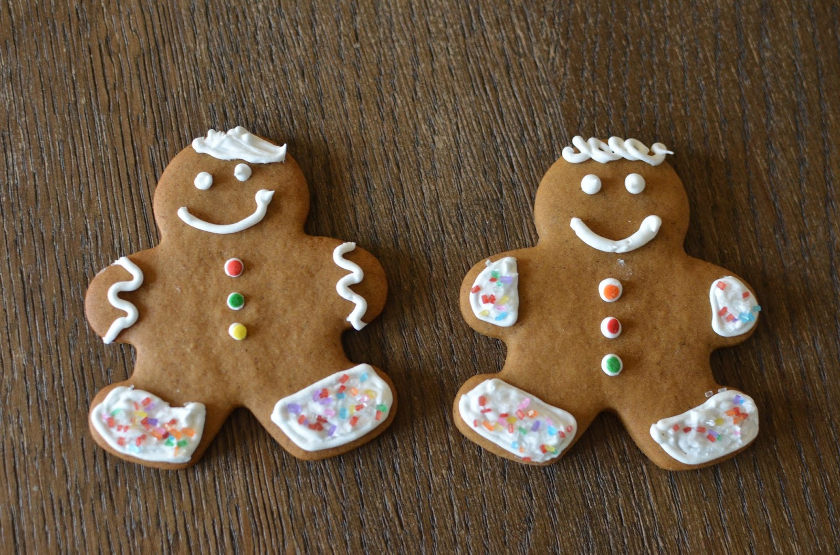

Christmas & New Year’s
There will be no Administration, housekeeping or Maintenance at the Lodge on Monday, December 25th, Tuesday, December 26th, and Monday, January 1st.
We hope you have a very Merry Christmas & a Happy New Year!!

New Staff
A warm welcome also foes to the people who joined our team in the past few months!

We hope that you enjoy your time here!

Noticeboard
cold & flu season
Everyone can do their part to help prevent the spread of colds and flu by following a few simple precautions. Please us hand sanitizer and proper handwashing frequently and be extra cautious when going on outings as there are some outbreaks in our community.
Let’s keep everybody safe and healthy by following these few simple precautions.
Thank You

THANK YOU
FCSS would like to express a heartfelt “THANKYOU” to the residents of Peter Dawson Lodge for the generous donation of the Halloween candy and chips to the food bank.

Secret Santa
Secret Santa has so much fun filling residents’ stockings each year. Santa would welcome whatever donations Residents and their families could contribute to the stockings.

In today’s day and time.
Its easy to lose sight,
Of the true meaning of
CHRISTMAS
And that one speacial night.
Brian K. Walters

christmas decorating
Sherry will begin
decorating the lodge for
Christmas the week of
November 27th everyone
is welcome to help. We will
decorate the Christmas trees the afternoon of Monday, December 4th.
Please join me in the Atrium on Thursday, December 7th at 2:00 pm for a hot beverage and to sign Christmas cards for past Residents, Staff and Volunteers.

reminder
Please let the kitchen staff or Sherry know if you will be away for any meals during the holidays!!
,

Laughing Matters

I carry a stone with me to throw at anyone who sings Christmas carols before Thanksgiving.
It’s my Jingle Bell rock.

What’s a dog’s favorite Christmas carol?
Bark the Herald Angels Sing.

Why should you take a ladder with you when you go Christmas caroling?
So you can reach the high notes.

What is a skunk’s favorite Christmas carol?
Jingle Smells.

A copy of A Christmas Carol fell on my toe…
It hurts like the Dickens!

