|  |  |
| --- | --- |
| NEWSLETTER  April 2024  Peter Dawson Lodge, 614 1St St N, 403-485-2422 | |
|  | **IN THIS ISSUE**  **Editor’s Desk ..………… 2**  **Month in Review ………. 3**  **Upcoming Events …….. 5**  **April Calendar ………. 6**  **April Birthdays ……… 7**  **A Poem to Share .…….. 8**  **Noticeboard ……………. 9**  **Laughing Matters …….. 10**  **Spotlight ………………… 11**  **Word Search …………… 12** |

# Editor’s Desk

Hello Residents, Families and Friends!

Happy April! Another new month greets us, and this one is full of more sunshine, flowers, and blue skies. There is so much to celebrate, and I hope you’ll join us for any of our events this month.

Please welcome Sherry and Darcie as the Directors of Resident Care. You will recognize them from around the lodge.

We hope to see you at any of our events this month– the more, the merrier!

To keeping things beautiful,   
Darcie and Sherry

**Quote of the Day**

The earth laughs in flowers.

– Ralph Waldo Emerson

**April Trivia**

It is thought that the name April comes from the Latin word "to open" and describes the trees opening at springtime.

Zodiac signs: **Aries & Taurus**Birthstone: **Diamond**

Flower: **Daisy & Sweet Pea**



**In April, we celebrate Birthdays with:**

* **April 9 – Doris C (Resident)**
* **April 10 – Gladys C (Resident)**
* **April 26 - Alma (Re**
* **sident)**
* **April 28 – Jeanette (Resident)**

**Please wish these beautiful people a Happy Birthday on their special day!**

# Month in Review

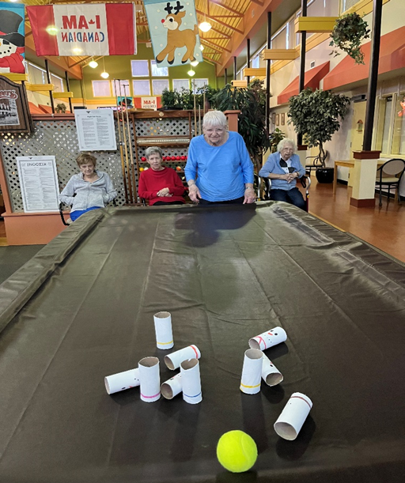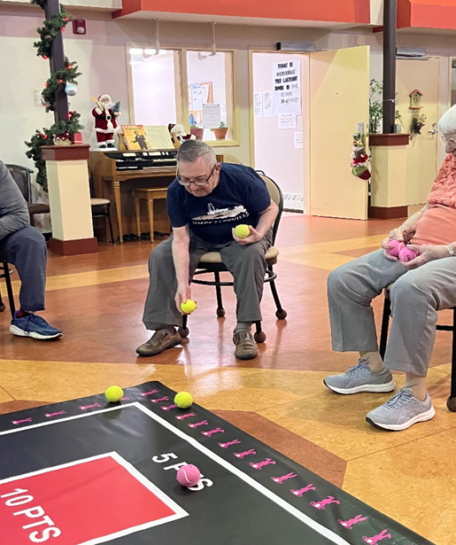

The ladies enjoying playing a tabletop game. Playing Rollerball

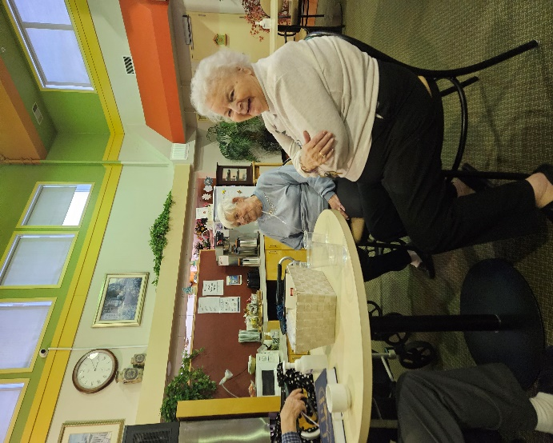

Playing Shuffleboard

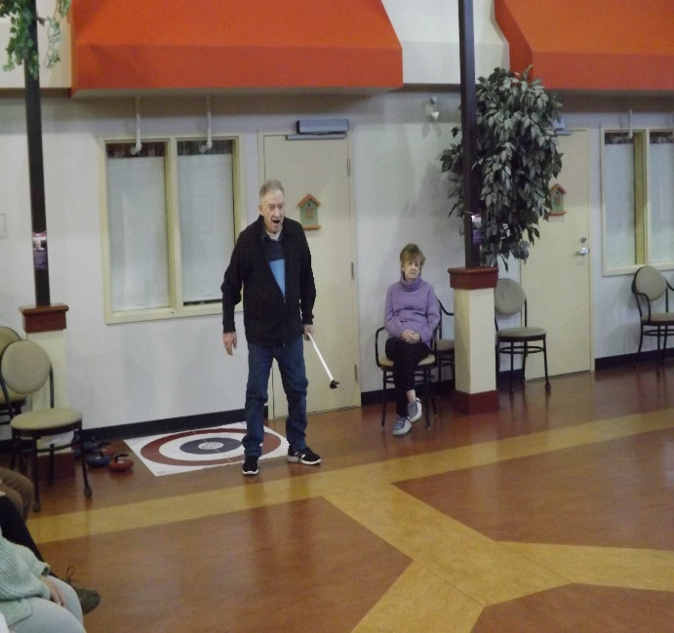

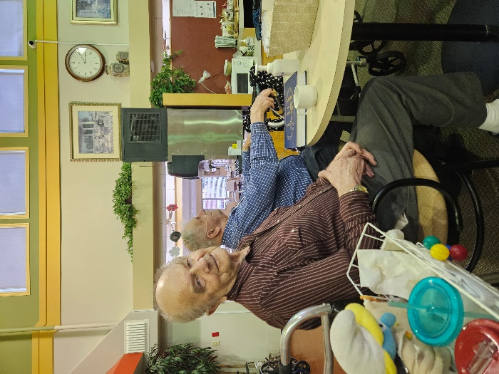

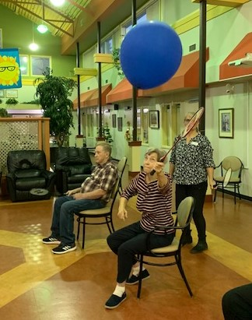

Thank you Sherry for doing such a great job, in such a short time!

Mary Lou enjoying time in the garden. The weather has been beautiful and residents have been enjoying spending time outdoors.

# Upcoming Events

**Special Days**

1st April Fools’ Day

2nd Children’s Book Day

5th Walk to Work Day

11th Barbershop Quartet Day

12th Human Space Flight

22nd Mother Earth Day

22nd Passover Begins

23rd Shakespeare’s Bday

23rd World Book Day

26th Arbor Day

29th Intl. Dance Day

**Resident’s Meeting**  
April 2 at 10:30am in the Atrium

**Entertainment Highlights for the Month**

Bob (Keyboardist) April 4

Highland Dancers April 5

Music with Mike April 11

Billy Joseph April 26

Regular Events

Exercises every day at 10:30 except Mon and Fri

Hairdresser every Thursday by appointment

|  |  |  |  |  |  |  |
| --- | --- | --- | --- | --- | --- | --- |
|  | · April 2024 · | | | | |  |
| ∙ **Sunday** ∙ | ∙ **Monday** ∙ | ∙ **Tuesday** ∙ | ∙ **Wednesday** ∙ | ∙ **Thursday** ∙ | ∙ **Friday** ∙ | ∙ **Saturday** ∙ |
| **Happy Easter!** | |  | | --- | | **1** | |  |   EASTER MONDAY  6:30 Good News  No admin or housekeeping | |  | | --- | | **2** | |  |   9:00 Balloon Badminton  10:30 Resident Meeting  2:45 Bingo for Prizes | |  | | --- | | **3** |   9:00 Roller Ball  10:30 Exercise Class with Ana from Kona Fitness  2:30 Dominoes | |  | | --- | | **4** |   9:00 Bocce Ball  10:30 Pool Noodle Exercises  1:00 Reader’s Build  2:30 Bob—Keyboardist  Hairdresser Day | |  | | --- | | **5** |   9:00 Floor Curling  10:30 Bible Study  1:00 Walking Outside  2:30 Highland Dancers  6:30 Social Hour | |  | | --- | | **6** |   10:30 Pool Noodle Exercises |
| |  | | --- | | **7** |   10:30 Pool Noodle Exercises  2:30 Dice | |  | | --- | | **8** |   9:00 Bean Bag $2  1:00 FCSS  3:00 Uno  6:30 Good News | |  | | --- | | **9** |   9:00 Balloon Badminton  10:30 Exercises  2:45 Obie Games | |  | | --- | | **10** |   9:00 Roller Ball  10:30 Exercises  2:30 Kerplunk | |  | | --- | | **11** |   9:00 tabletop Curling  10:30 Exercises  2:30 Music with Mike | |  | | --- | | **12** | |  |   9:00  10:30 Bible Study  3:00 Ice Cream $2 | |  | | --- | | **13** |   10:30 Pool Noodle Exercises |
| |  | | --- | | **14** |   10:30 Pool Noodle Exercises  2:30 Dice | |  | | --- | | **15** | |  |   9:00 Shuffleboard $2  1:00 FCSS  3:00 Skip Bo  6:30 Good News | |  | | --- | | **16** |   9:00 Balloon Badminton  10:30 Exercises  2:45 Obie Games | |  | | --- | | **17** |   9:00 Roller Ball  10:30 Exercises  2:30 Dominoes | |  | | --- | | **18** |   9:00 Kerplunk  10:30 Exercises  1:00 Readers Build | |  | | --- | | **19** |   9:00 Floor Curling  10:30 Bible Study  3:00 Happy Hour | |  | | --- | | **20** |   10:30 Pool Noodle Exercises |
| |  | | --- | | **21** |   10:30 Pool Noodle Exercises  2:30 Anglican Church | |  | | --- | | **22** | |  |   9:00 Bean Bag $2  1:00 FCSS  3:00 Walking Outside  6:30 Good News | |  | | --- | | **23** | |  |   9:00 Balloon Badminton  10:30 Exercises  1:30 Crafts | |  | | --- | | **24** | |  |   9:00 Roller Ball  10:30 Exercises  2:45 Bingo for prizes | |  | | --- | | **25** | |  |   9:00 Bocce Ball  10:30 Exercises  2:00 Neighborly Visit At the Lodge | |  | | --- | | **26** | |  |   9:00 Soccer  10:30 Bible Study  3:00 Monthly Birthday Music by Billy Joseph | |  | | --- | | **27** |   10:30 Pool Noodle Exercises |
| |  | | --- | | **28** |   10:30 Exercises  2:30 Dice  Happy Birthday Jeanette | |  | | --- | | **29** |   9:00 Shuffleboard $2  1:00 FCSS  3:00 Walking Outside  6:30 Good News | |  | | --- | | **30** |   9:00 Balloon Badminton  10:30 Exercises  3:00 |  | | | |



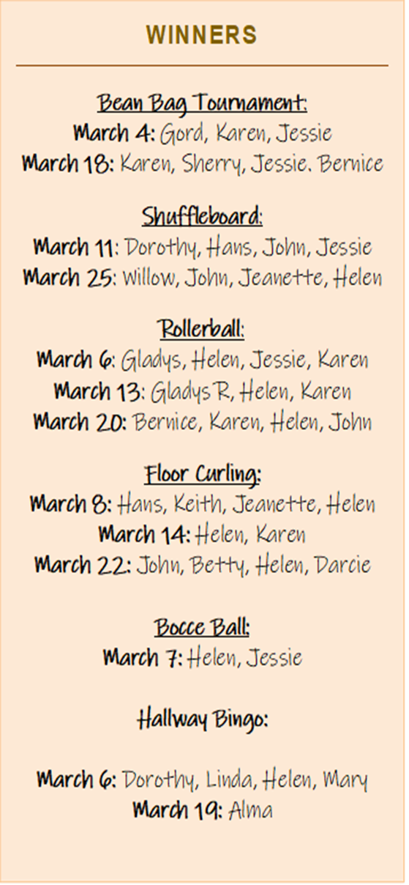

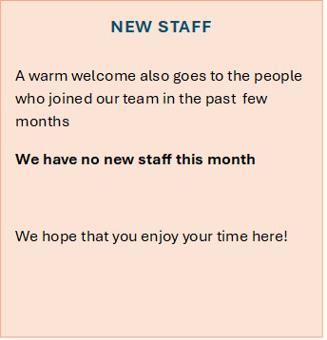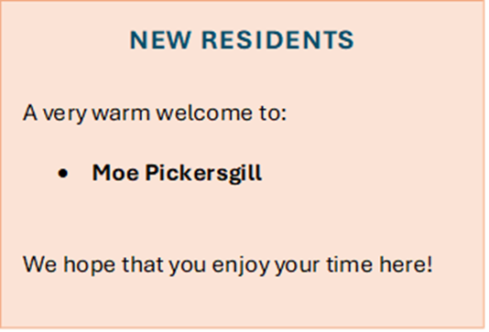

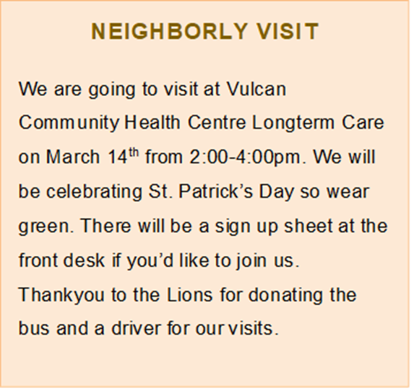

# Poem to Share

**The Gardener**

by Mary Oliver

Have I lived enough?  
Have I loved enough?  
Have I considered Right Action enough, have I come to any conclusions?  
Have I experienced happiness with sufficient gratitude?  
Have I endured loneliness with grace?

I say this, or perhaps I’m just thinking it.  
Actually, I probably think too much.  
  
Then I step out into the garden,  
where the gardener, who is said to be a simple man,  
is tending his children, the roses.

# Noticeboard





**THANK YOU**

We would like to issue a heartfelt thanks to relatives and volunteers who support us day in and day out. You make such a difference, and we so very much appreciate your time and energy.

# Laughing Matters



**Jokes**How many of these can get you to laugh (or groan)?

Why don’t ants get sick?  
*Because they have little ant-bodies.*

Why did the cloud go to the doctor?  
*Because it was feeling under the weather.*

What do clouds wear under their coats?  
*Thunderwear!*

What did the recycling bin say to the trash can?  
*“You’re garbage…but I love you anyway!”*

Did you hear about the tornado that married a cloud?  
*The wedding was a whirlwind!*

What do you call a snowman in the summer?  
*A puddle.*

How do trees access the internet?  
*They log on, of course.*

Why did the tree go to the dentist?  
*To get a root canal.*

What do you call it when worms take over the world?  
*Global worming!*

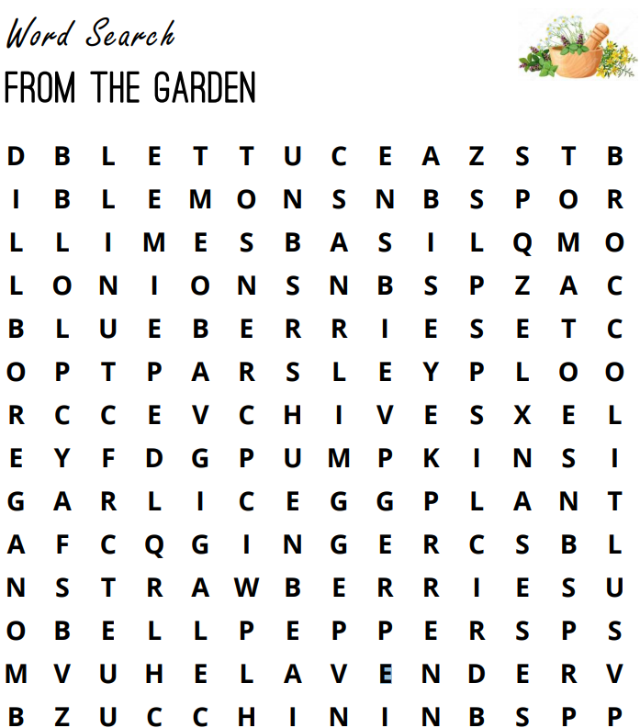

Bell Peppers Strawberries Lavender Dill Chives

Parsley Lettuce Basil Garlic Pumpkins

Ginger Oregano Lemons Limes Tomatoes

Blueberries Zucchini Eggplant Onions Broccoli