NEWSLETTER

March 2024

Peter Dawson Lodge 614 1St St N, Vulcan, AB, T0L 2B0
IN THIS ISSUE

  - Editor’s Desk ..………… 2
  - Month in Review ………. 3
  - Upcoming Events …….. 5
  - March Calendar ………. 6
  - March Birthdays ……… 7
  - Journaling Prompts ….. 8
  - Noticeboard ……………. 9
  - Laughing Matters …….. 10
  - Anagrams……………….. 12

Editor’s Desk

Hello Residents, Families and Friends!
I am really looking forward to this month – there is so much to celebrate! Join us at any of our events and programs that celebrate St. Patrick’s Day, Spring, Easter, and more. It’s sure to be a busy month at our community and I hope you’ll be a part of all the fun!
This month, consider harnessing a little luck and trying your hand at a new activity or program. You just might meet a new friend or find a new hobby…if you’re lucky!
Here’s to March!
Sherry Kunkel
Director of Resident Care
Quote of the Day
When I’ve least expected it, an enormous opportunity or stroke of luck has crossed right under my nose.
– Julie Andrews

March Trivia

March was named after Aka, the Roman God of War, a mythical ancestor of the Romans and father of Romulus and Remus.

Zodiac signs: Pisces & Aries
Birthstone: Aquamarine
Flower: Daffodil
Music with The Dixons

Our residents enjoy their old-time music. You can see many toes tapping, hands clapping and singing along.

Life in Our Community
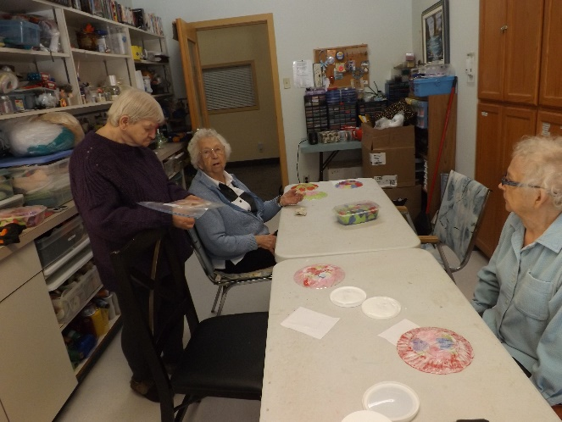

Craft Day

We made stain glass plates for the dining room windows out of tissue paper hearts.
They turned out lovely when the sun shines through them.
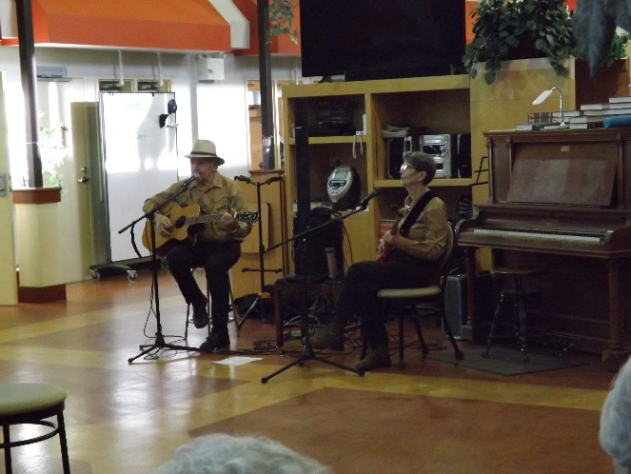
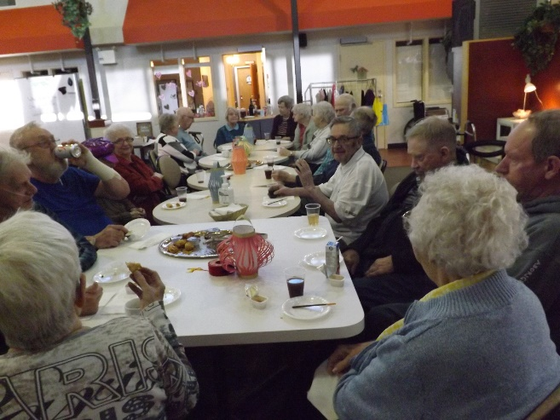
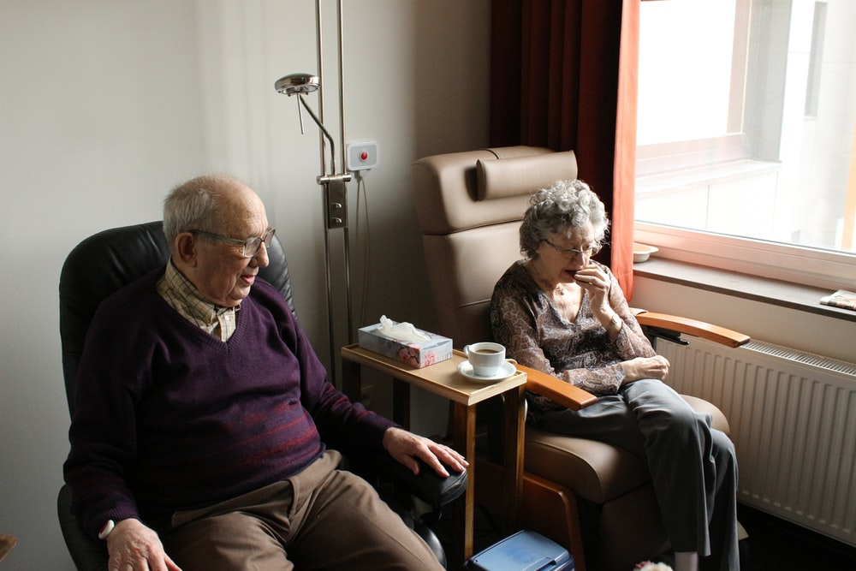
Chinese New Year

We celebrated a day early with Chinese appetizers and happy hour. Our residents enjoyed the lanterns and learning about the year of the wood dragon. The fortune sticks were fun and we had lots of laughs as each fortune was revealed.
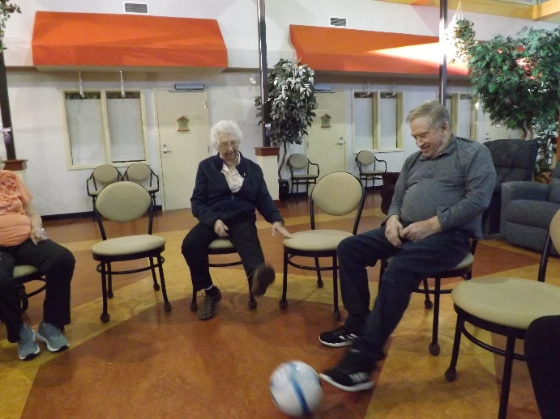
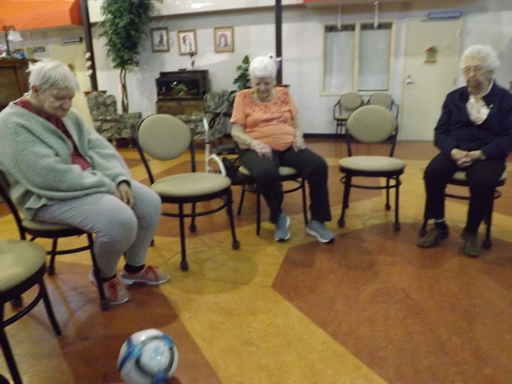
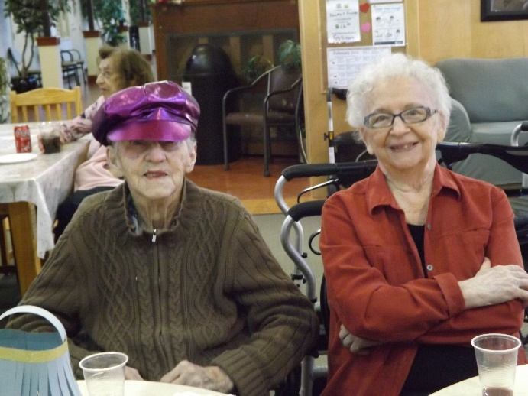
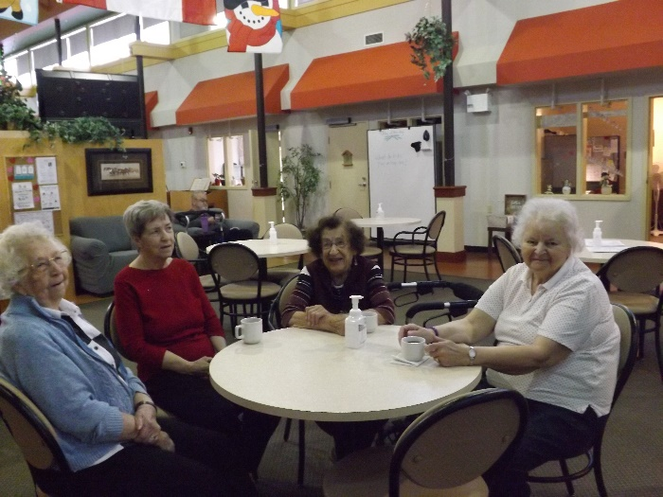
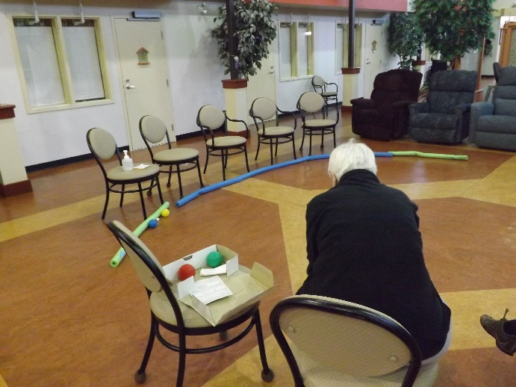
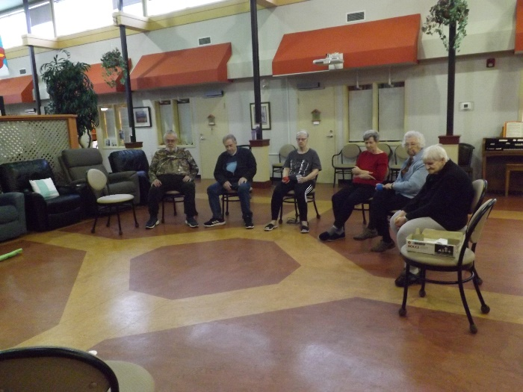
Ladies visiting over coffee

Mary Lou enjoying time in the garden. The weather has been beautiful and residents have been enjoying spending time outdoors.
Bocce Ball

Mary Lou enjoying time in the garden. The weather has been beautiful and residents have been enjoying spending time outdoors.
Chinese New Year

Mary Lou enjoying time in the garden. The weather has been beautiful and residents have been enjoying spending time outdoors.
Soccer Circle

Mary Lou enjoying time in the garden. The weather has been beautiful and residents have been enjoying spending time outdoors.

What We’ve Been Up To

Upcoming Events

Resident’s Meeting
Tuesday March 5th at 10:30am in Atrium
Neighborly Visit
Thursday March 14 at 2:00pm at VCHC
United Church Service
Tuesday March 19 at 6:30pm in Atrium
Special Days

1st World Day of Prayer
3rd Caregiver Appreciation Day
8th Intl. Women’s Day
10th Mothering Sunday (UK)
15th The Ides of March
17th St. Patrick’s Day
19th First Day of Spring (N. Hemisphere)

21st World Poetry Day
24th Palm Sunday
25th Greek Independence
31st Easter

Rainey Day Music
Thursday March 28th 2:00pm, Atrium
Monthly Birthday Party
Friday March 28 at 3:00pm, Atrium

Regular Events

FCSS every Monday at 1:00pm
Hairdresser every Thursday by appointment
Exercises at 10:30am except Monday and Friday’s Bible Study Friday at 10:30am
Dice Sunday at 2:30pm
Bingo! Every 2nd Wednesday 2:30pm
 | March 2024 ·
∙ Sunday ∙ | ∙ Monday ∙ | ∙ Tuesday ∙ | ∙ Wednesday ∙ | ∙ Thursday ∙ | ∙ Friday ∙ | ∙ Saturday ∙
In March Winter is holding back and Spring is pulling forward…. |  |  |  |  | 1  9:00 Soccer  10:30 Bible Study  3:00 Uno  6:30 Social Hour | 2  10:30 Exercises  2:30 Obie Games
3  10:30  Exercises  2:30 Dice | 4  9:00 Bean Bag  1:00 FCSS  3:00 Minute to Win It  6:30 Good News | 5  9:00 Balloon Badminton  10:30 Resident Meeting  3:00 Rummikub | 6  9:00 Roller Ball  10:30 Exercises  2:30 Bingo | 7  9:00 Bocce Ball  10:30 Exercises  2:30 Music with Mike | 8  9:00 Floor Curling  10:30 Bible Study  3:00 Yahtzee  6:30 Social Hour | 9  10:30 Exercises  2:30 Card Bingo
10  10:30  Exercises  2:30 Dice | 11  9:00 Shuffleboard  1:00 FCSS  3:00 What’s In The Bag  6:30 Good News | 12  9:00 Balloon Badminton  10:30 Exercises  1:30 Craft | 13  9:00 Roller Ball  10:30 Exercises  3:00 Left, Right, Centre | 14  9:00 Table Curling  10:30 Exercises  2:00 Neighborly Visit to VCHC | 15  9:00 Soccer  10:30 Bible Study  3:00 St. Patrick’s Day Happy Hour | 16  10:30 Exercises  2:30 31 Card Game
17  10:30  Exercises  2:30 Dice  St. Patrick’s Day | 18  9:00 Bean Bag  1:00 FCSS  3:00 Envelope Game  6:30 Good News | 19  9:00 Balloon Badminton  10:30 Exercises  3:00 Darts  6:30 United Church | 20  Spring  9:00 Roller Ball  10:30 Exercises  2:30 Bingo | 21  9:00 Bocce Ball  10:30 Exercises  2:00 Music with Keith and Marilyn | 22  9:00 Floor Curling  10:30 Bible Study  3:00Dominos  6:30 Social Hour | 23  10:30 Exercises  2:30 Obie Games
24  10:30  Exercises  2:30 Dice | 25  9:00 Shuffleboard  1:00 FCSS  3:00 Spoons  6:30 Good News | 26  9:00 Balloon Badminton  10:30 Exercises  3:00 Left, Right, Centre | 27  9:00 Roller Ball  10:30 Exercises  3:00 Bunny Funnies & Egg Coloring | 28  9:00 Table Curling  10:30 Exercises  1:00 Reader’s Build  3:00 Rainey Day Music and Birthday Party | 29  9:00 Soccer  3:00 Uno  6:30 Social Hour  Good Friday | 30  10:30 Exercises  2:30 Chase the Ace
31  Easter  10:30  Exercises  2:30 Dice | March may come in like a Lion but will go out like a Lamb

March Birthdays

In March, we celebrate birthdays with:

- March 6 – Gerry S (resident)
- March 15 – Dorreen (resident)
- March 21 – Hailey (staff)
- March 25 – Linda (resident)

Please join us in the Atrium on March 28th to celebrate
our March birthdays!!

Pisces (Feb 19 – Mar 20)
Pisces are friendly and selfless. They are always willing to help others

Aries (Mar 21 – Apr 20)
Aries are passionate, motivated and confident leaders. They are bundles of energy & enthusiasm.
There are many superstitions about luck. How many of these will bring you good luck, and how many will bring you bad luck, according to superstition?
- Opening an umbrella indoors
- Knocking on wood
- Throwing salt over your shoulder
- Walking under a ladder
- Finding a heads up penny
- Eating 12 grapes on New Year’s Eve
- Breaking a mirror or Having an itchy palm
Historical Events in March: The Lindbergh Baby Kidnapping
On March 1, 1932, Charles Lindbergh Jr. was kidnapped from the family mansion in Hopewell, New Jersey. He was 20 months old and the son of aviation hero Charles Lindbergh, who flew the first solo flight across the Atlantic Ocean. The baby was never returned, even after the family paid $50,000 in ransom.

Journaling Prompts

Grab your journal and jot down your answers to these questions. Or, if you’d prefer, use this list as a fun way to start conversations with family members or neighbors. Remember, there’s no right or wrong answers here and you can choose to share what you are comfortable with. Have fun!

- Who is the luckiest person you know? Why are they so lucky, do you think?
- Is there a such thing as luck, or is it all hard work and determination?
- Write about a time you felt like everything was going your way and you were quite lucky.
- How would you tell someone to get through a period of their life when they felt they were having bad luck and nothing was going the way they wanted?
- What are some superstitions you’ve heard about luck? Can you think of any for being lucky in love, or about luck for a marriage?
- When is the last time you felt lucky or blessed? Can you write down five things you’re thankful for today?
- Did you every do anything fun or silly for St. Patrick’s Day when you were a kid? What about when you were an adult? Write about your favorite St. Patrick’s Day traditions.
- Write a poem or story about a leprechaun who has lost directions to his rainbow.

.
New Residents
A very warm welcome to:
- Ory Doane
- Rose Munro
- Bernice Stark
We hope that you enjoy your time here!
!
Here’s to the women!
Did you know that that majority of staff at our community are women? We are so thankful for all of the women who serve our residents so well, in all of their roles. This month, as we celebrate International Women’s Day, be sure to thank all the women in your life who have made you who you are today!

If you have time, think about a few women who changed your life for the better. Write about them or share their stories!

Noticeboard

out and about
We are fortunate enough to have access to transportation that our residents can use to take excursions around town or for local appointments. The Courtesy Car is available on Wednesday’s when we have a driver available. Thank you to the special people who volunteer their time and vehicles to help our residents with transportation.
There is a sign-up sheet at the front desk if you’d like to utilize this service.

M
Sunday March 31, 2024

Activity Surveys
Thankyou to all the residents who completed the activity surveys. We appreciate your time and suggestions. We will try to incorporate more of the activities everyone enjoys into the calendars and maybe try something new.

Noticeboard
Winners
Bean Bag Tournament

February 5 – Jessie, Karen & John

Roller Ball

February 7 – John, Jessie, Betty & Gord
February 14 – Gladys, Jeanette, Helen & Karen
February 28 – Gladys R, Jessie & Helen

Bocce Ball

February 8 – Jessie
February 22 - Gord

Floor Curling

February 9 – Hans, Helen, John & Jeanette
February 23 – Gord, Jessie, Jeanette & Willow

Tabletop Curling

February 15 – John, Gord & Sherry

Shuffleboard

February 12 – Karen, Betty, Jessie & Sherry
February 19 – Helen, Jeanette, John & Hans
February 26 – Gerald, Jeanette, Jessie & John

Bingo
February 16 - Dorothy
Daylight Savings Time
Reminder
On Sunday March 10th, 2024, Daylight Savings Time begins. Remember to “Spring ahead” by moving your clocks ahead one hour. It will be darker in the mornings again, but we will have more daylight in the evenings to enjoy.

Neighborly Visit
We are going to visit at Vulcan Community Health Centre Longterm Care on March 14th from 2:00-4:00pm. We will be celebrating St. Patrick’s Day so wear green. There will be a sign up sheet at the front desk if you’d like to join us. Thankyou to the Lions for donating the bus and a driver for our visits.

Good Friday March 29th and Easter Monday April 1st. There will be no Housekeeping or Admin at the lodge on these days.

Laughing Matters

Did you know…
Laughing truly is the best medicine? When you laugh, your body releases neuropeptides which protect the body and mind from stress and potentially serious illnesses. So a few belly laughs each day can boost your immune response and keep you from feeling stressed out! In addition, laughing helps to reduce negative thoughts, boosts overall body functioning, and can contribute to positive mental health. It’s always a good time for a silly joke and a chuckle, no matter how cheesy the joke is. Here are a few for you this month!

I have a photographic memory. I just keep forgetting to develop it.

I showed my grandson a photo of his great-grandparents. I asked him if I looked like them and he said, “not yet, you don’t.”

I used to have my ducks all in a row, but now they’re all over the place quacking.

Did you hear about the new corduroy pillow? It’s making headlines everywhere.

I told my doctor I broke my arm in three places. He said, “You should stop going to those places.”

What’s blue and not very heavy?
Light blue.

Why did the man fall down the well? Because he didn’t see that well.

