NEWSLETTER

February 2024

Peter Dawson Lodge, Box 750, 614 1St N, Vulcan, AB, T0L 2B0, 403-485-2422
FEBRUARY 14, 2024

HAPPY VALENTINE’S
DAY!
HELLO FEBRUARY

Editor’s Desk

Hello Residents, Families and Friends!
January started out as a quiet month at the lodge with us being on outbreak. We missed seeing some of our residents’ wonderful faces when they were under the weather. We are back to our regular activities and loving it.
We’re all lucky here in our community to feel like family! With Random Acts of Kindness week and Valentine’s Day coming up this month, we can have the opportunity to show appreciation and
some extra kindness to one another. Sometimes a kind word or smile can mean the world to another person.
Wishing you all a Happy February. Stay Warm!
Sherry Kunkel
Director of Resident Care
Something to Think About
Who, or what, is the greatest love of your life?
February Trivia

2024 is a leap year! This means you’ll find an extra day in February this year. What will you do with it?

Zodiac signs: Aquarius & Pisces
Birthstone: Amethyst
Flower: Primrose
New Year’s Cards
Our resident’s have been enjoying looking at the cards that Vulcan Prairie View Elementary School made for them wishing them a Happy New Year for 2024. They appreciate the messages in each card.

What We’ve Been Up To
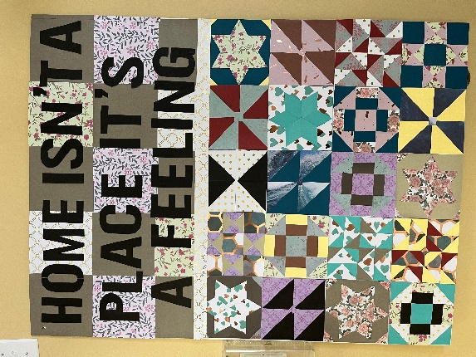
Craft Day

Our residents are glad to be back to some of our regular activities. On craft day we made quilt squares from paper and put them together into a community quilt. The residents enjoyed choosing their pattern and fabric(paper) for this project. Our quilt is hanging in the dining room for everyone to enjoy.
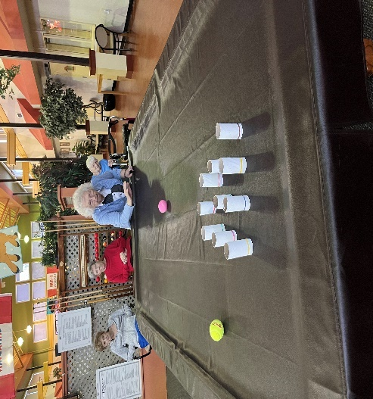
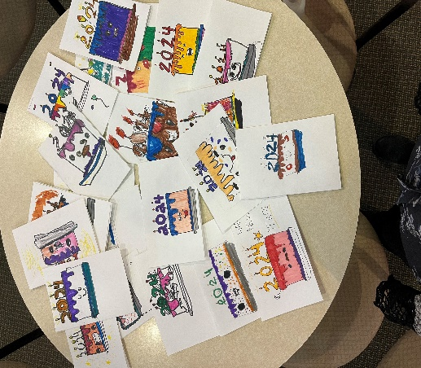
Snowman Bowling

With the cold weather and snowfall, we thought it would be fitting for our residents to enjoy a bit of winter indoors with snowman bowling. They loved the challenge of knocking the snowmen over to earn points. We had a lot of fun and laughs with this new sport.
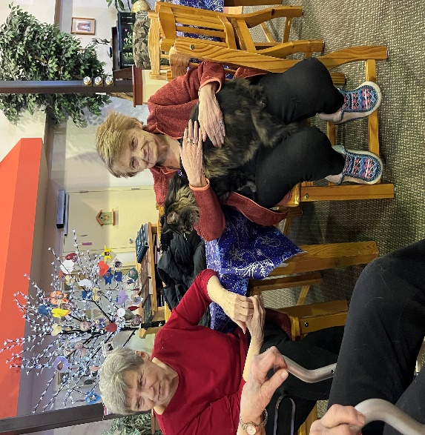
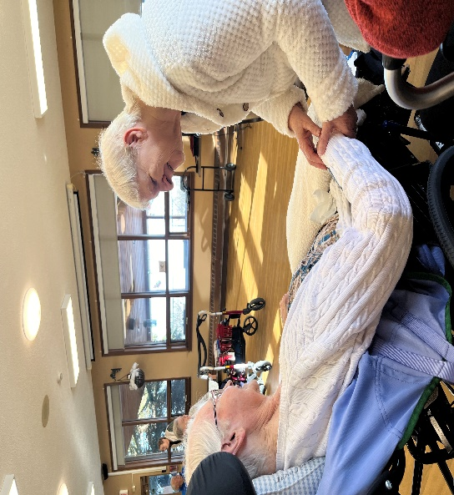
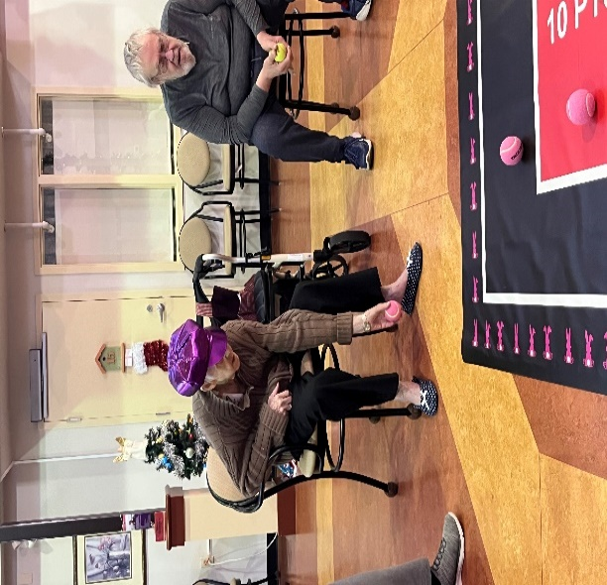
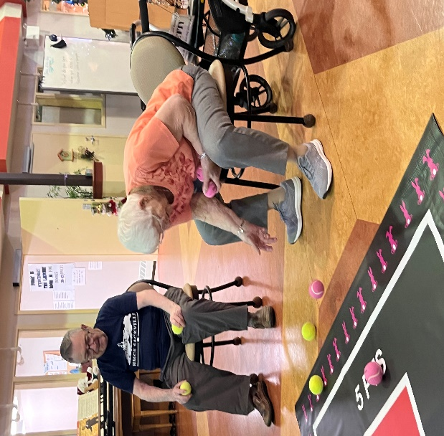
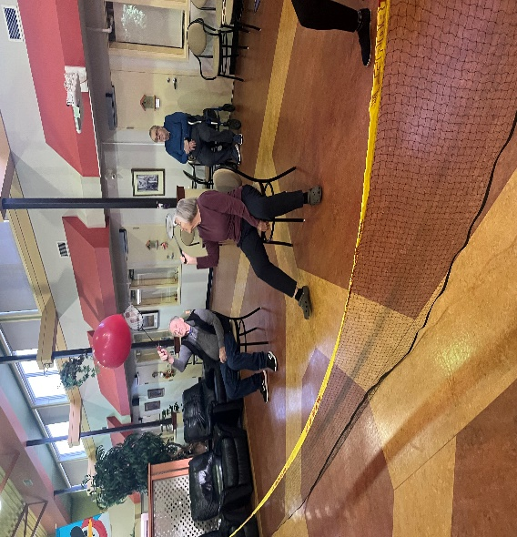
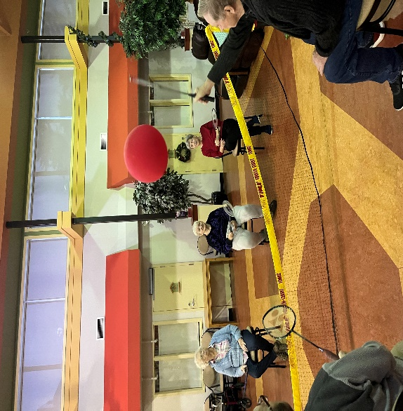
Neighborly Visit to Extendicare
Pet Visit

Mary Lou enjoying time in the garden. The weather has been beautiful and residents have been enjoying spending time outdoors.
Balloon Badminton is always fun keeping the balloon in the air.
Roller Ball is a favorite activity every Wednesday.

Mary Lou enjoying time in the garden. The weather has been beautiful and residents have been enjoying spending time outdoors.

Around Our Community

Upcoming Events

Resident’s Meeting
Tuesday February 6th at 10:30am in Atrium
Music with Kelly
Thursday February 8th at 2:30pm in Atrium
Chinese New Year’s and Happy Hour
Friday February 9th at 3:00pm in Coffee Area
Valentine's Celebration
Wednesday February 14th at 3:00pm
Movie Afternoon
Tuesday February 20th in the Atrium
Special Days in February
1st Black History Month
5th Read Aloud Day
6th Waitangi Day (NZ)
12th Abe Lincoln’s Bday
13th Mardi Gras
13th Galentine’s Day
14th Valentine’s Day
18th Drink Wine Day
21st Language Day
22nd Baden-Powell’s Bday
29th Leap Day

Monthly Birthday Party
Thursday February 29th at 3:00pm in Coffee Area

Regular Events

Good News Music every Monday at 6:30pm
Balloon Badminton every Tuesday at 9:00am
Roller Ball every Wednesday at 9:00 am
Hairdresser every Thursday
Bible Study every Friday at 10:30am
Dice Game every Sunday at 2:30pm

 | · February 2024 ·
∙ Sunday ∙ | ∙ Monday ∙ | ∙ Tuesday ∙ | Wednesday ∙ | ∙ Thursday ∙ | ∙ Friday ∙ | ∙ Saturday ∙
 |  |  |  | 1  9:00 Balloon Badminton  10:30 Pool Noodle Exercises  2:00 Old Time Country Music | 2  Groundhog Day  9:00 Soccer  10:30 Bible Study  3:00 Matching Game  6:30 Social Hour | 3  10:30 Pool Noodle Exercises  2:30 Uno
4  10:30 Pool Noodle Exercises  2:30 Dice | 5  9:00 Shuffleboard  1:00 FCSS  3:00 31 Card Game  6:30 Good News | 6  9:00 Balloon Badminton  10:30 Resident Meeting  1:30 VPE Valentine’s | 7  9:00 Roller Ball  10:30 Exercises  3:00 Bingo | 8  9:00 Bocce Ball  10:30 Pool Noodle Exercises  2:30 Music with Kelly | 9  9:00 Floor Curling  10:30 Bible Study  3:00 Chinese New Year & Happy Hour $2 | 10  Chinese New Year  10:30 Pool Noodle Exercises  2:30 Card Bingo
11  10:30 Pool Noodle Exercises  2:30 Dice | 12  9:00 Bean Bag  3:00 Chase the Ace  6:30 Good News | 13  9:00 Balloon Badminton  10:30 Exercises  3:00 Craft | 14  Valentine's Day  9:00 Roller Ball  10:30 Exercises  2:30 Valentine’s Celebration | 15  9:00Tabletop Curling  10:30 Pool Noodle Exercises  1:00 Reader’s Build  3:00 Cranium Crunches | 16  9:00 Soccer  10:30 Bible Study  3:00 Left, Right, Centre  6:30 Social Hour | 17  10:30 Pool Noodle Exercises  2:30 Phase 10
18  10:30 Pool Noodle Exercises  2:30 Dice | 19  Family Day  10:30 Pool Noodle Exercises  3:00 31 Card Game | 20  9:00 Balloon Badminton  10:30 Exercises  2:00 Movie Afternoon | 21  9:00 Roller Ball  10:30 Exercises  3:00 Hangman and Pet Visit | 22  9:00 Bocce Ball  10:30 Pool Noodle Exercises  2:00 Neighborly Visit | 23  9:00 Floor Curling  10:30 Bible Study  3:00 Ice Cream $2  6:30 Social Hour | 24  10:30 Pool Noodle Exercises  2:30 Crib
25  10:30 Pool Noodle Exercises  2:30 Dice | 26  9:00 Bean Bag  3:00 Chase The Ace  6:30 Good News | 27  9:00 Balloon Badminton  10:30 Exercises  3:00 Left, Right, Centre | 28  9:00 Roller Ball  10:30 Exercises  3:00 Rummikub | 29  9:00Table Top Curling  10:30 Pool Noodle Exercises  2:00 Monthly Birthday Party

February Birthdays

In February, we celebrate birthdays with:

- February 18th – Sherry K -staff
- February 25th – Gladys R -resident
- February 25th – Hal O -staff
- February 27th – Eugene W – resident

Please join us in wishing them a Happy Birthday!

Aquarius (Jan 20 – Feb 18)
Aquarians are shy & quiet deep thinkers who love helping others.

Pisces (Feb 19 – Mar 120)
Pisces are friendly and selfless. They are always willing to help others
Mardi Gras in New Orleans
In New Orleans, Mardi Gras parades happen for weeks before Fat Tuesday, where parade participants throw beads to watchers. Beads often get caught in the trees that line the streets. Instead of climbing a ladder to cut them down, residents simply keep the beads in the trees, creating Mardi Gras trees that celebrate year-round!
Could you create a Mardi Gras tree in your room with the beads you collect this month?
Galentine’s Day?
Not all love is a romantic love. Celebrating the friends you love is the purpose of a new “holiday”, Galentine’s Day! Friends gather for glasses of wine or a relaxed dinner to show their appreciation for one another.
.
THANK YOU
We would like to issue a heartfelt thanks to relatives and volunteers who support us day in and day out. You make such a difference, and we so very much appreciate your time and energy.

February 11-17 is Random Acts of Kindness Week. Your kindness might make a world of difference to somebody. Take this opportunity to perform random acts of kindness and inspire others to do the same. Together we can make the world a better place, one act of kindness at a time.

Noticeboard

wINNERS
bingo
January 14- Dorothy
Bean Bag
January 8 – Gord, Helen&Karen
January 22- Karen, John& Jeanette
Roller Ball
January 10- Helen, Jeanette, Karen& Gladys R
January 17 – John, Gord, Sherry, & Jessie
January 24- Jessie, Karen, Jeanette& Gladys R
Floor Curling
January 12 – Gord, jeanette, john & helen
What do you think?
What do you love about our community? We’d love to hear your thoughts. Jot down your favorite things about our community and turn it into us. We might share your answer in our newsletter, bulletin board, or social media!

Hairdresser
Our hairdresser Izzy will be at the lodge on February 27 instead of February 29. She will be away on February 29th.

Laughing Matters

Love Jokes
I must be a snowflake because I fell for you.

Did you hear about the near-sighted porcupine? He fell in love with a pincushion.

A couple is on a date at an expensive restaurant. The woman tells the man to tell her something that will get her heart racing. He says, “I forgot my wallet.”

I’m no photographer but I can picture us together.

If I could rearrange the alphabet, I would put U and I together.

Are you a banana? Because I find you a-peeling.

I know this is going to sound cheesy, but I think you are the grate-est.

How did the telephone propose to its partner? It gave her a ring.

My new girlfriend works at the zoo. I think she’s a keeper.

What’s the difference between love and marriage? Love is blind. Marriage is an eye-opener.

Never laugh at your wife’s choices. You’re one of them.

Why shouldn’t you fall in love with a pastry chef? Because they will dessert you.

