NEWSLETTER

January 2024

Peter Dawson Lodge
614 1St N, Box 750 Vulcan, AB, T0L 2B0
403-485-5422

IN THIS ISSUE

  - Editors Desk ..………… 2
  - Month in Review ………. 3
  - Upcoming Events …….. 5
  - January Calendar ……… 6
  - January Birthdays …….. 7
  - Conversation Starters .. 8
  - Noticeboard ……………. 9
  - Laughing Matters …….. 11
  - Spotlight ………………… 12
  - Word Scramble .……… 13

Editor’s Desk
Hello Residents, Families and Friends!
Happy New Year! Can you believe we are greeting 2024 when it seems like 2023 was just starting? I’m wishing peace, health, and happiness for all of us.
Do you make resolutions this time of year? Perhaps I can encourage you to consider it as we move into 2024. Science and research have proven that staying socially active is key to healthy aging. Connecting with others in events and activities boosts the immune system, decreases anxiety, and enhances quality of life. Staying social can also decrease the risk of heart disease and cognitive decline.
We’re challenging you to attend at least 3 activities each week this month. Attend a favorite program or try a new group. In either case, you’ll reap the benefits of healthy socialization! Let our team help you find your next favorite event.
Here’s to new adventures!
Sherry Kunkel
Director of Resident Care
Journaling Prompt
What are you looking forward to in 2024? How do you hope the year surprises you?

What is one new activity you could join this month?
January Trivia

January was named after the Roman god Janus; the god of beginnings & transitions.

Zodiac signs: Capricorn & Aquarius
Birthstone: Garnet
Flower: Carnations

What We’ve Been Up To

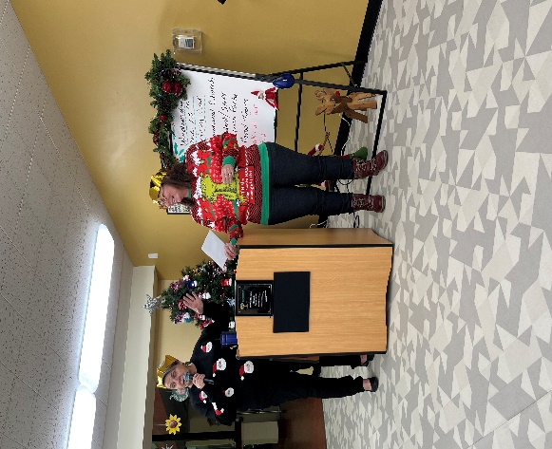
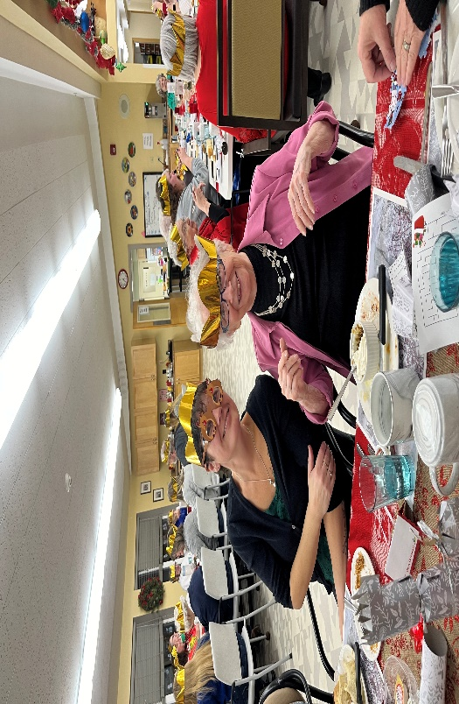
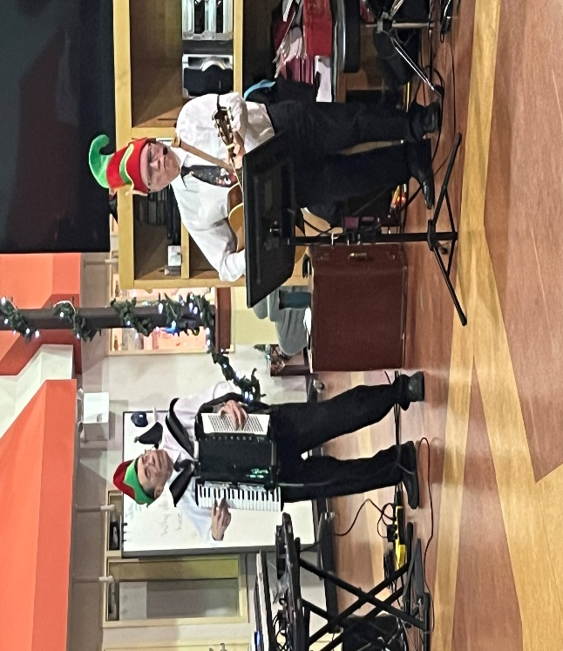
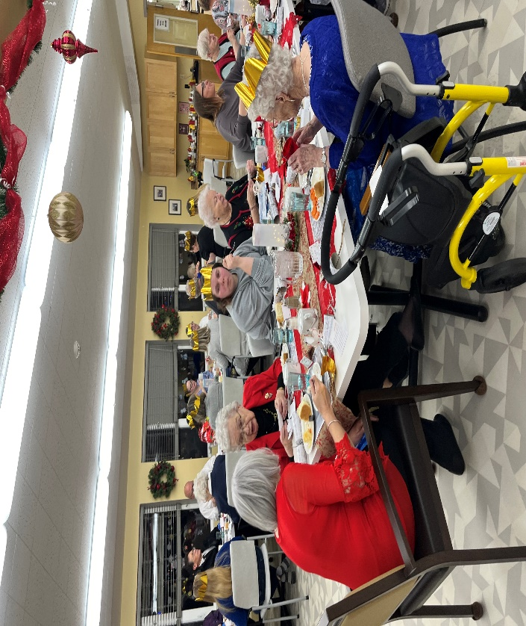
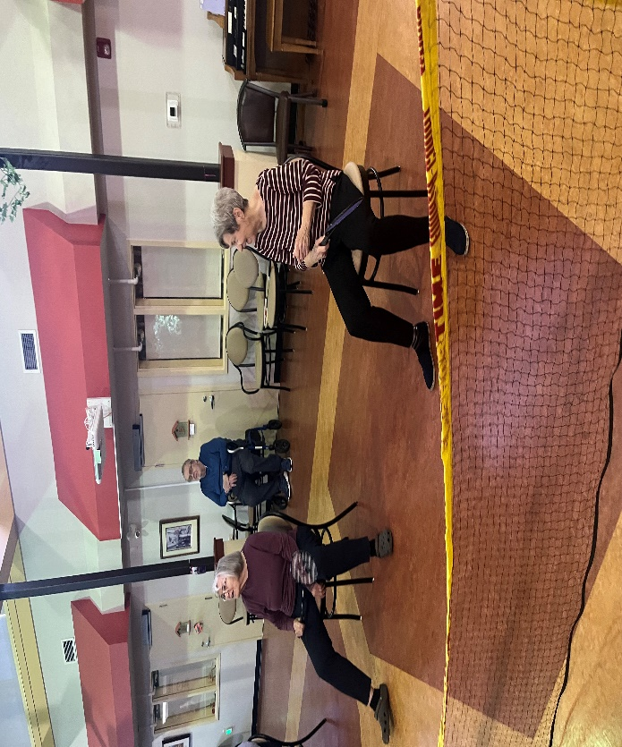
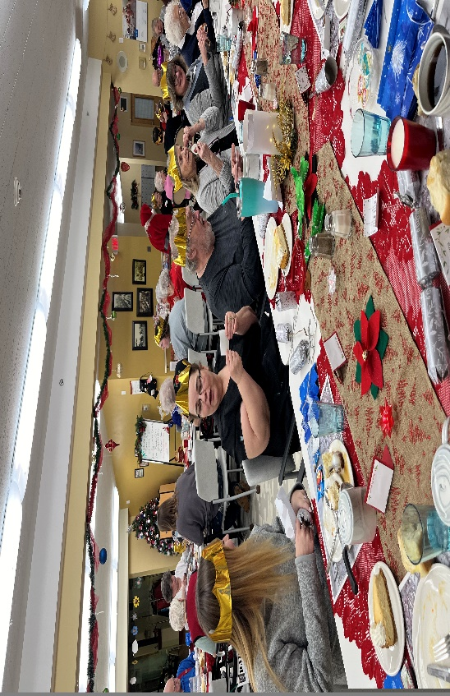
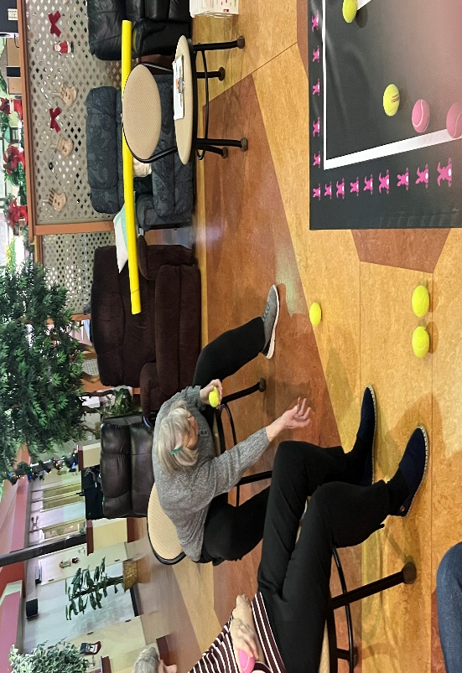
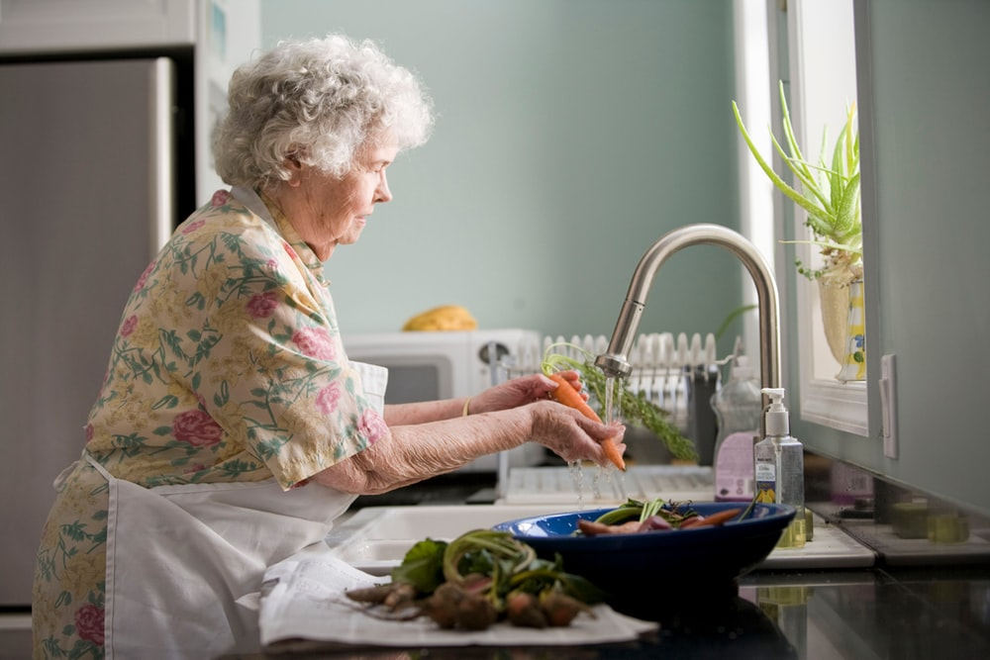
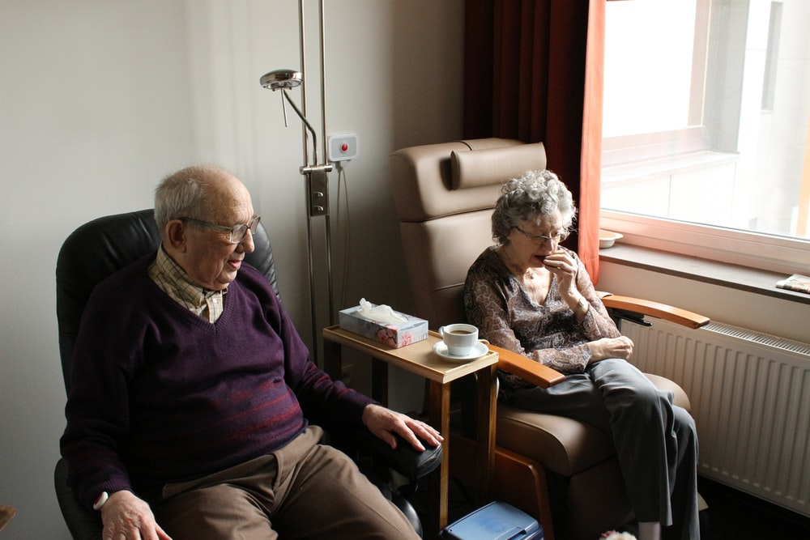

Resident and Staff Christmas Party
held December 13th.
Residents and Staff enjoyed themselves at the annual Christmas Party. We had great food, conversation, laughs, a raffle, music, dancing and a visit from Santa. It was a fun evening!
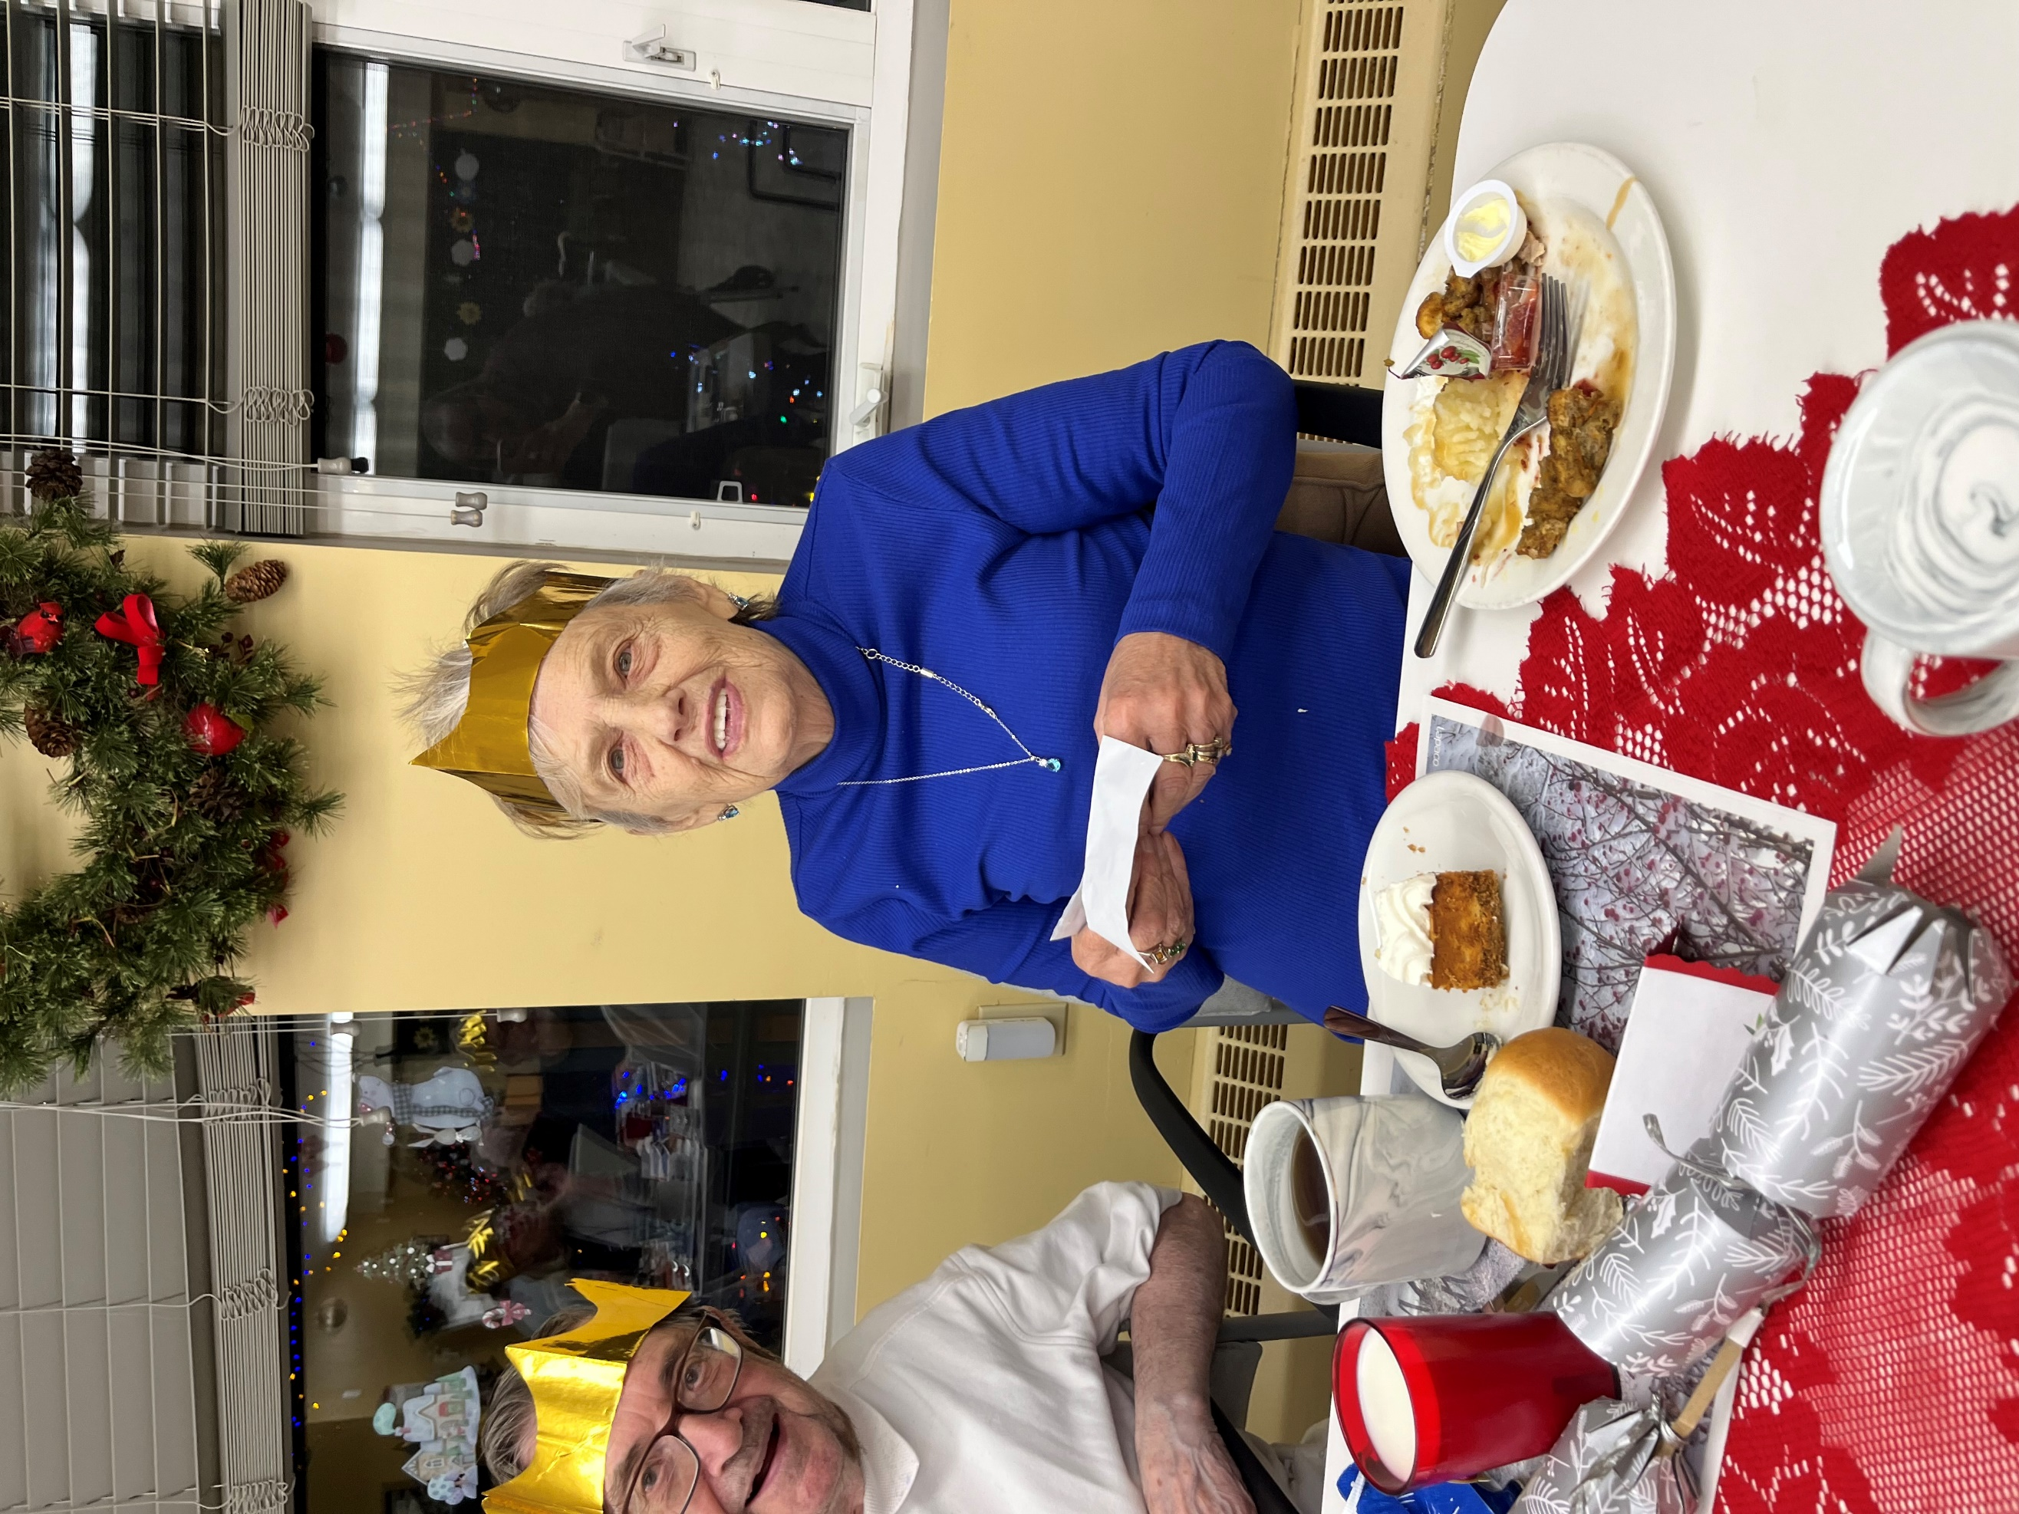
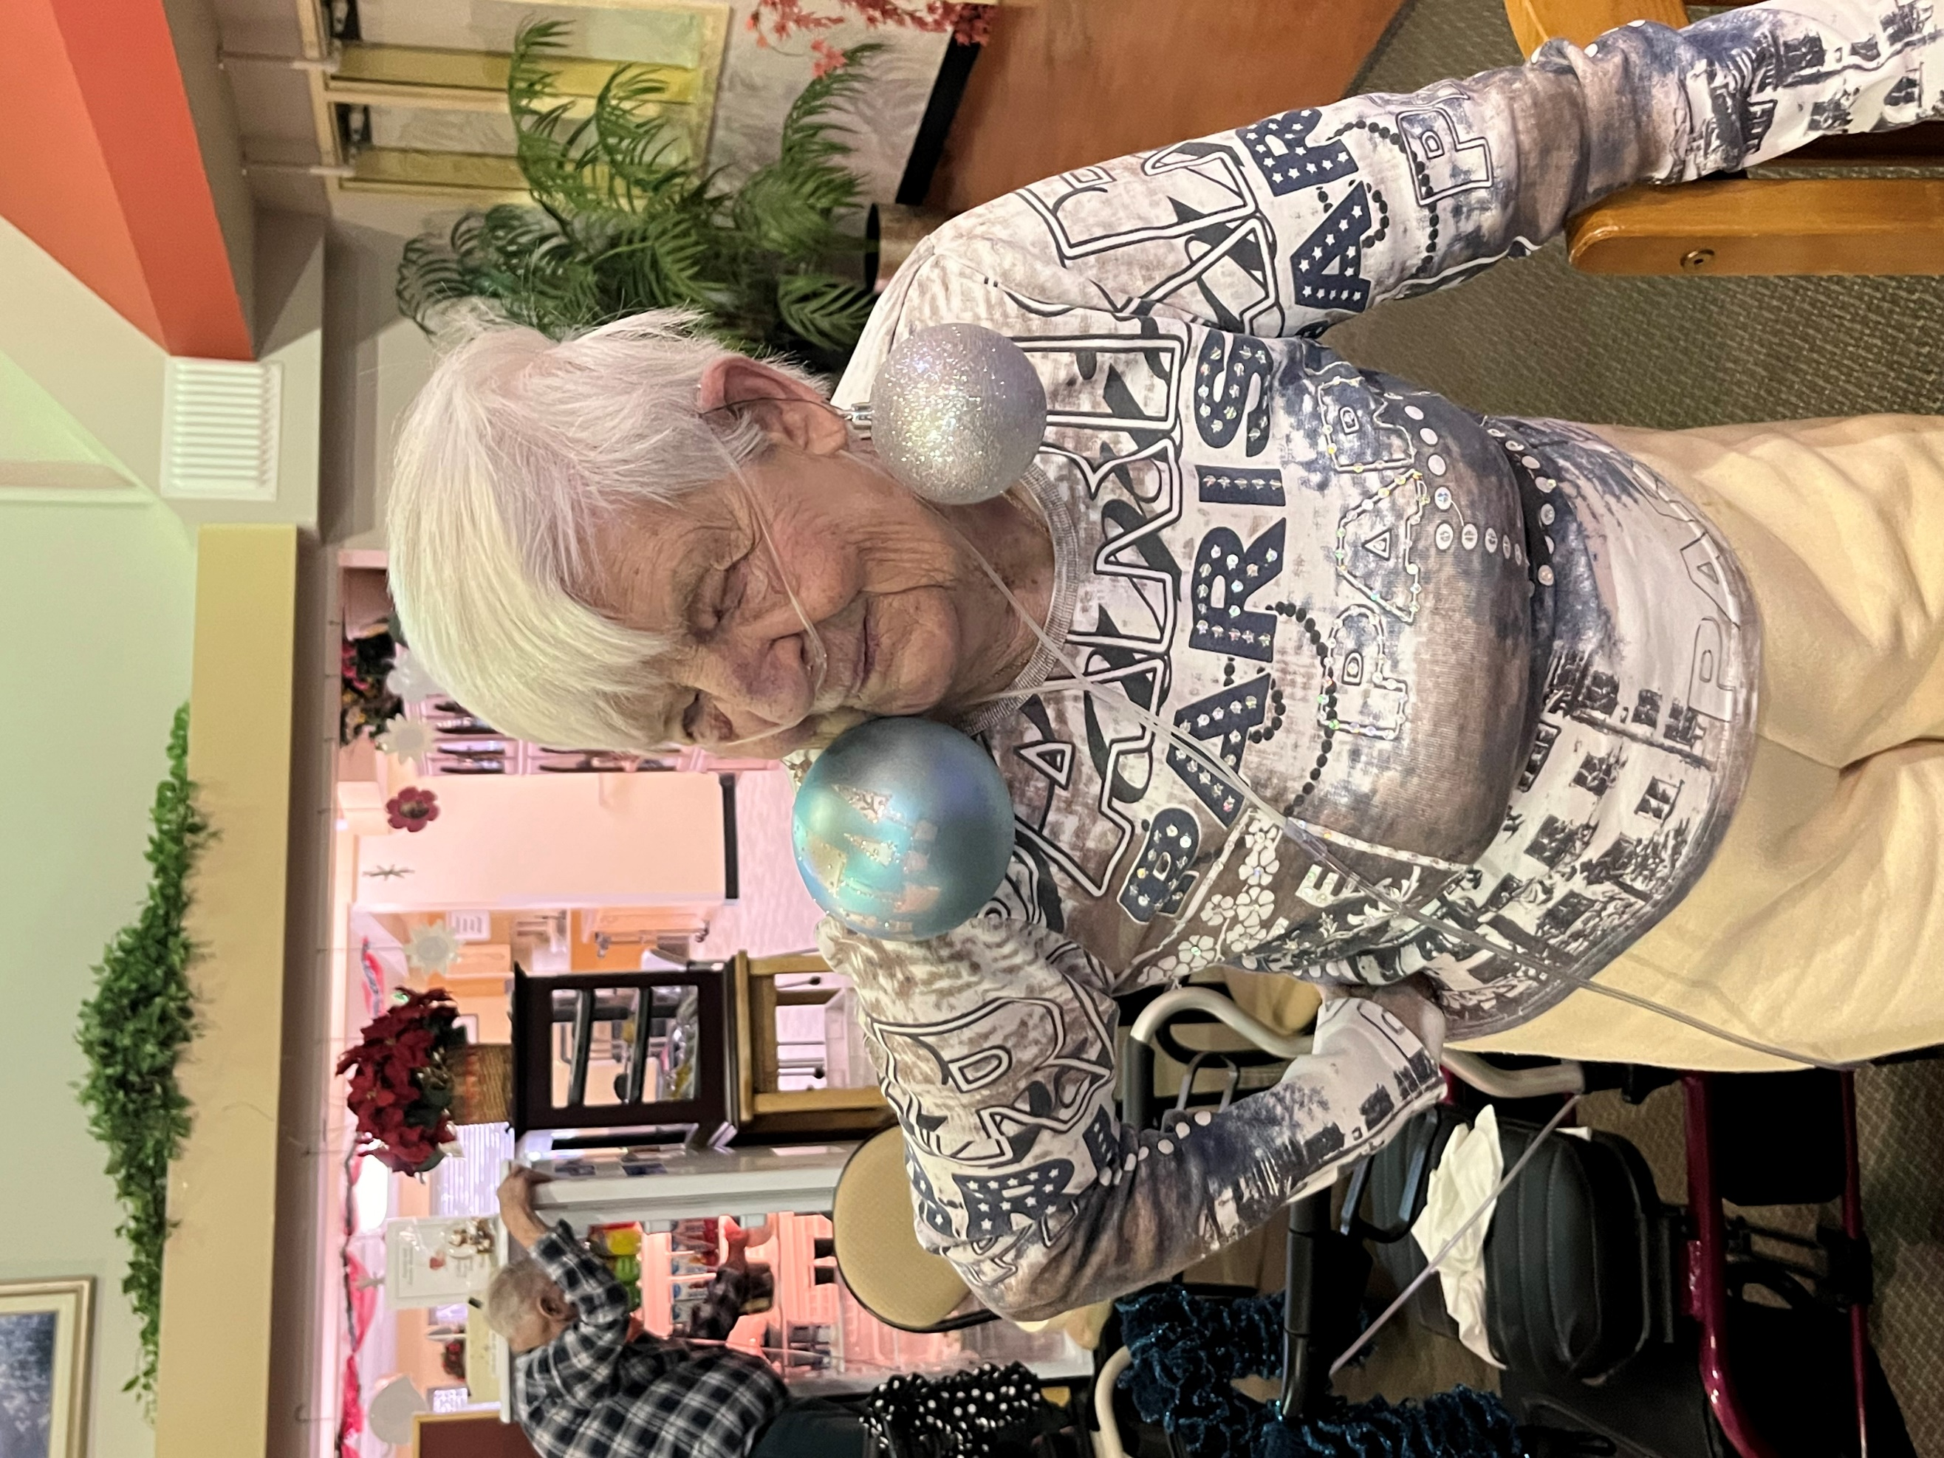
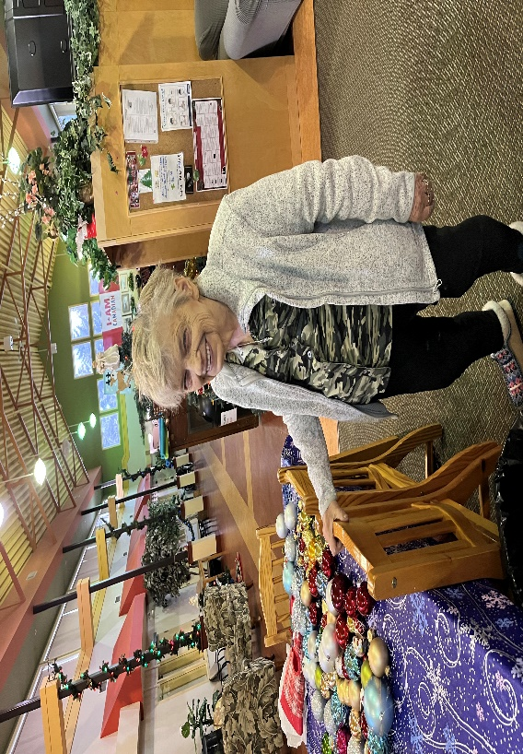
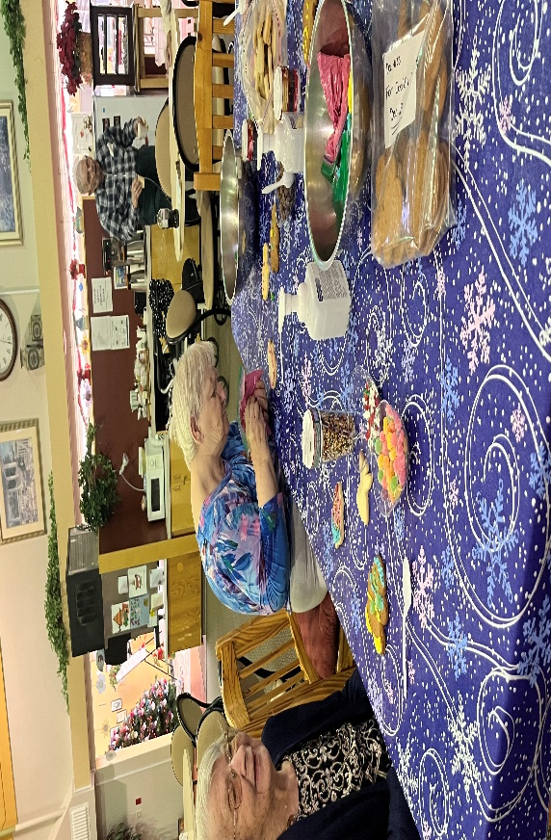
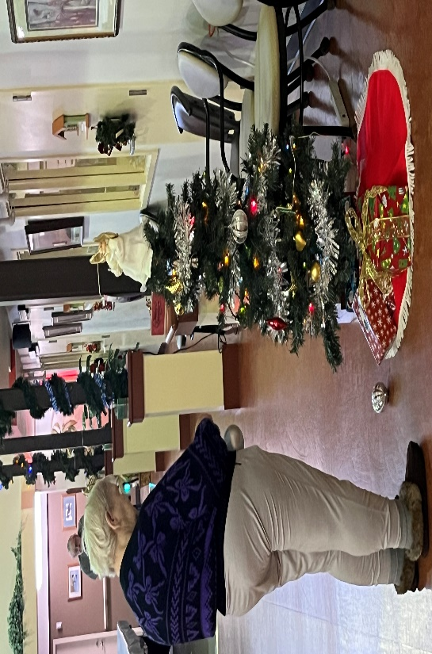
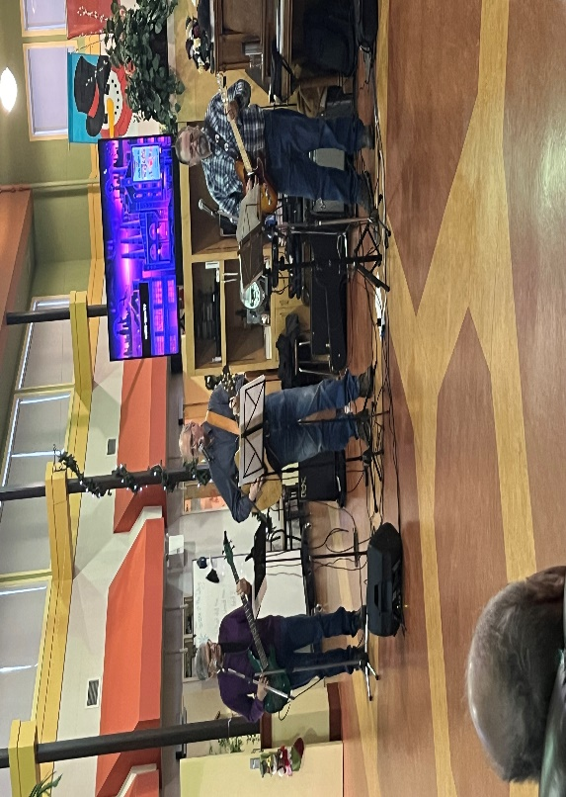
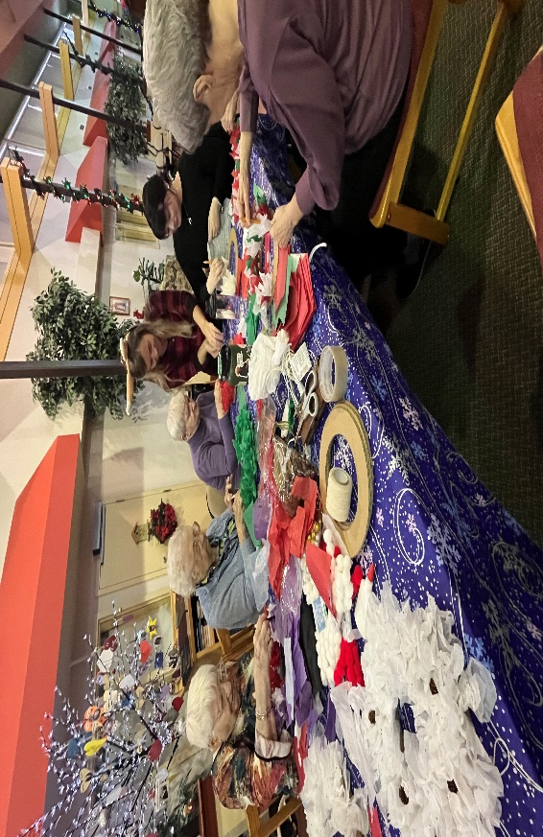
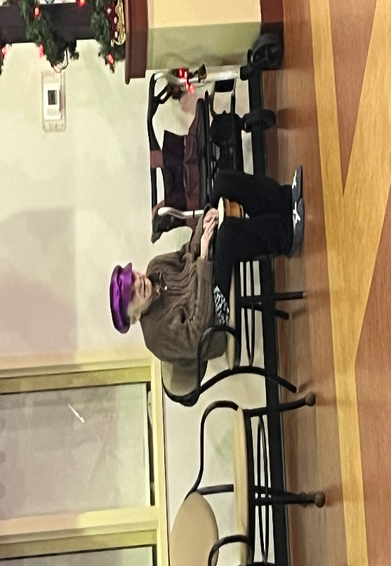
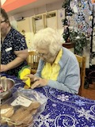
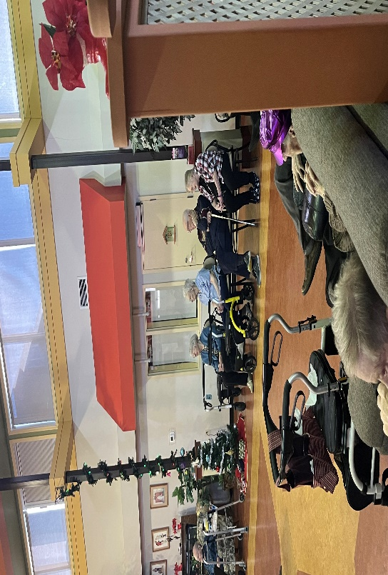
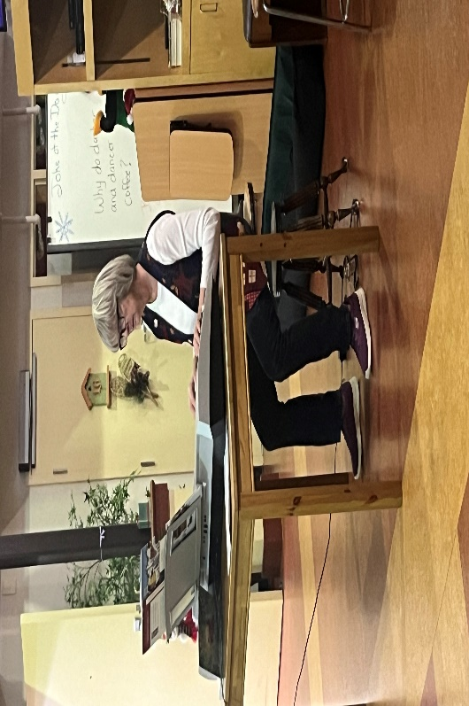
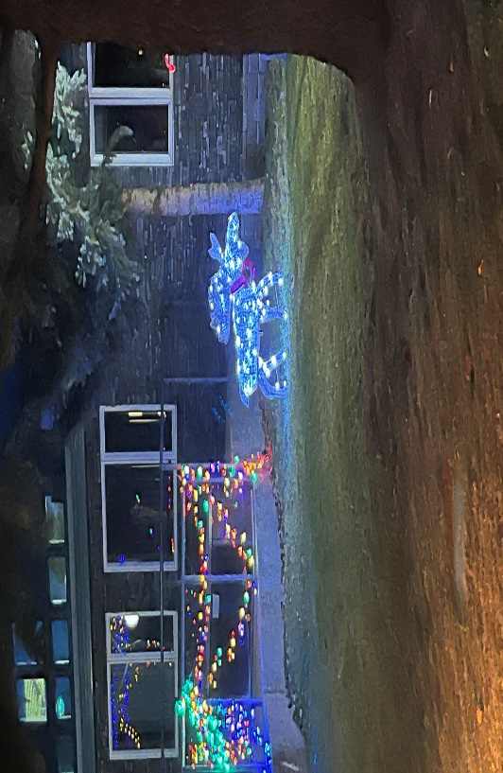
Resident enjoying the music and playing along on her drum.

Mary Lou enjoying time in the garden. The weather has been beautiful and residents have been enjoying spending time outdoors.
Tour of Christmas lights. View from outside the lodge.

Mary Lou enjoying time in the garden. The weather has been beautiful and residents have been enjoying spending time outdoors.
Craft with FCSS ladies

Mary Lou enjoying time in the garden. The weather has been beautiful and residents have been enjoying spending time outdoors.
Christmas Tree Decorating

Mary Lou enjoying time in the garden. The weather has been beautiful and residents have been enjoying spending time outdoors.
Christmas Cookie decorating

Mary Lou enjoying time in the garden. The weather has been beautiful and residents have been enjoying spending time outdoors.
Music with Harvey’s Son’s

Mary Lou enjoying time in the garden. The weather has been beautiful and residents have been enjoying spending time outdoors.

Life at Our Community

Upcoming Events

Pet Visit
January 23 at 3:00 in Atrium

Resident’s Meeting
Tuesday 2 of January 10:30am in Atrium

Neighborly Visit to Extendicare
Wednesday 24th of January 2:00pm

Craft
Special Days

1st Hot Tea Day
3rd Tolkien’s Birthday
6th Epiphany
8th Elvis Presley’s Birthday
16th MLK Day
18th Sundance Film Festival
19th Intl. Flower Day
21st Intl. Hug Day
24th Natl Compliment Day
26th Australia Day
27th Mozart’s Birthday

Tuesday 9 of January 1:30pm, Craft Room

Church Service
Sunday 28th January and Tuesday 30th of January at 6:30pm

Monthly Birthday Party
Friday 26th of January 3:00pm, Atrium

Regular Events

Bean Bag Every other Monday at 9 am
Good News every Monday at 6:30pm
Hairdresser every Thursday by appointment
Exercises Tues, Wed, Thurs and weekend at 10:30am
Dice Saturday and Sunday at 2:30pm

 | · January 2024 ·
∙ Monday ∙ | ∙ Tuesday ∙ | ∙ Wednesday ∙ | ∙ Thursday ∙ | ∙ Friday ∙ | ∙ Saturday ∙ | ∙ Sunday ∙
1  9:00Bean Bag  3:00 Chase the Ace  No Housekeeping or Admin | 2  9:00 Balloon Badminton  10:30 Resident Meeting  3:00 Rummikub | 3  Courtesy Car  9:00 Rollerball  10:30 Chair Exercises  3:00 Darts | 4  9:00 Bocce Ball  10:30 Exercises  1:00 FCSS  3:00 Bingo | 5  9:00 Floor Curling  10:30 Bible Study  3:00 Memory Game  6:30 Social Hour | 6  10:30 Exercises  2:30 Dice | 7  10:30 Exercises  2:30 Dice
8  9:00 Shuffleboard  3:00 Memory Game  6:30 Good News | 9  9:00 Balloon Badminton  10:30 Exercises  1:30 Craft | 10  Courtesy Car  9:00 Rollerball  10:30 Chair Exercises  3:00 Yahtzee | 11  9:00 Ring Toss  10:30 Exercises  1:00 FCSS  3:00 Music with Diane | 12  9:00 Floor Curling  10:30 Bible Study  3:00Ice Cream  6:30 Social Hour | 13  10:30 Exercises  2:30 Dice | 14  10:30 Exercises  2:30 Dice
15  9:00Bean Bag  3:00 Chase the Ace  6:30 Good News | 16  9:00 Balloon Badminton  10:30 Exercises  3:00 Obie Games | 17  Courtesy Car  9:00 Rollerball  10:30 Chair Exercises  3:00 Snowman Boiwling | 18  9:00 Bocce Ball  10:30 Exercises  1:00 FCSS  3:00 Uno | 19  9:00 Floor Curling  10:30 Bible Study  3:00 Happy Hour  6:30 Social Hour | 20  10:30 Exercises  2:30 Dice | 21  10:30 Exercises  2:30 Dice Day
22  9:00 Shuffleboard  3:00 Memory Game  6:30 Good News | 9:00 23 BalloonBadminton  10:30 Exercises  3:00 Pet Visit | 24  Courtesy Car  9:00 Rollerball  10:30 Chair Exercises  2:00 Neighborly Visit | 25  9:00 Bocce Ball  10:30 Exercises  1:00 FCSS  3:00 Music with Mike | 26  9:00 Floor Curling  10:30 Bible Study  3:00 Birthday Party  6:30 Social Hour | 27  10:30 Exercises  2:30 Dice | 28  10:30 Exercises  2:30 Dice
29  9:00Bean Bag  3:00 Chase the Ace  6:30 Good News | 30  9:00 BalloonBadminton  10:30 Exercises  3:00 Bingo  6:30 Church Service | 31  Courtesy Car  9:00 Rollerball  10:30 Chair Exercises  3:00 Ring Toss | HAPPY NEW YEAR AND ALL THE BEST IN 2024

January Birthdays

In January, we celebrate birthdays with:
- Resident - Keith Harris - Jan 3rd
- Staff – Susan C - Jan 3rd
- Resident - Donna Poth - Jan 23rd
- Resident - Betty McFadden – Jan 25th
- Resident - Margaret Shaw – Jan 26th

Please join us in wishing these residents a Happy Birthday!!

Capricorn (Dec 22 – Jan 19)
Capricorns are responsible, disciplined and have good managers

Aquarius (Jan 20 – Feb 18)
Aquarians are shy & quiet deep thinkers who love helping others.
Can you fill-in-the-blank these song lyrics?
It’s up to you, __________ York, ________ York!
What’s new, __________? Whoa, whoa, whoa.
I can see clearly now the _________ is gone.
It’s a new dawn, it’s a new day, it’s a new ________.
Start spreading the _________, I’m leaving today.
Should auld acquaintance be ________________.
One minute to say goodbye before we say _________.
I thought I’d ask you just the same, what are you doing on __________ _______________ ____________?
Elvis was born January 8, 1935.
Elvis Aaron Presley was born in January in Tupelo Mississippi to his parents, Gladys and Vernon. Little did they know that their little baby would grow up to be one of the first major rock stars of his generation with 40 top ten songs and 18 number one hits in his career!

Conversation Starters

Getting to Know Your Neighbors
Now that you know all the benefits of social connection – boosted immune system response, less anxiety and cognitive decline, and enhanced overall wellness – it’s time to start reaping those benefits by connecting with your neighbors. Making new friends can feel hard sometimes, so if you’re struggling or feeling shy, it’s okay! Our community is full of friendly and welcoming residents, which means you’re already one step closer to starting a meaningful conversation with a new friend.

You can also use conversation starters to strike up a chat with someone at your dining room table, someone sitting next to you at an event, or someone that you see sitting in the common room. You can also use conversation starters as journaling prompts for yourself! Families, you can also use any conversation starters during your next visit.

Here are a few conversation starters that you can try using over the next month. Cheers to new friendships!

- What is the best thing that happened to you today?
- Tell me about your childhood pet.
- What was your favorite part of the school day when you were younger?
- How are you feeling today?
- What do you like to do for fun?
- When is the last time you really belly laughed?
- What is your favorite hobby?
- Who is your favorite singer and why?
- Who is your favorite actor or actress?
- What is a favorite book that you have read?
- Who was your best friend in elementary school?
- Who was your favorite teacher?
- Do you have any new year resolutions?

Thank you to the Residents for their generosity and joining us for our PDL Christmas Party. We had a great time!! And we appreciate the assistance with Grace before supper and the presentation of the staff cards.

WINNERS
Shuffleboard
November 27- John C, Jessie, Dorothy & Karen
December 11- Jessie, John C, Dorothy & Helen

Roller Ball
November 29- Gord, John C, John N, Keith
Dec 6- Karen, Helen, Jessie & Gladys R

Bean Bag Tournament
Dec 4- Karen, John C, Sherry

Snowball Toss
Jeanette, Helen and Jessie

Floor Curling
December 15- Hans, Gord, Karen & Sherry

Noticeboard

New Staff
A warm welcome to the people who joined our team in the past month!
- Hailey Benett
We hope that you enjoy your time here!

CONGRATULATIONS

Congratulations to all the Residents and staff that won a prize at our Annual PDL Christmas Party.
Jessie Gene
Jeanette Gerry
Doris Howard
Susan K, Lynn & Robin

- Thank you to Flowers and Fancies and The Love family for the donation of their

Resident modelling her new earrings.

Noticeboard
Foot Care
Sole Worthy Foot care will be at the lodge again on February 9th and 25th. There will be a sign-up sheet at the front desk if you’d like to see foot care specialist. Cost is $55.
THANK YOU
We would like to issue a heartfelt thanks to relatives and volunteers who support us day in and day out. You make such a difference and we so very much appreciate your time and energy.

Thankyou
Thankyou to VPE, CCHS and Lomond Schools for coming in to share christmas music and cards with the residents at PDL. They enjoyed your visits and seeing your smiling faces.
New Year Math
If you multiply the months of 2024 and add that number to what time the ball drops in Times Square, what number do you get?
Stop by the Activity office to tell us your answer and see if you are right!

REMINDER
Please call the lodge or let a staff member know if you are not coming out for a meal,
along with leaving a note on your door. Staff will then know your plans prior to mealtime and will not come to your room to see if you are coming out. Thank you in advance!
Holiday Decorations
Now that the holiday hustle and bustle is over, we’ll be taking down our twinkle lights and decorations. Be sure you pack up any holiday decorations in your home as well, including any wreaths or trees you might have put up for the season.

Laughing Matters

Since the new year is knock, knock, knocking on our door, we present some of our favorite knock-knock jokes.
Knock knock.
Who’s there?
Peas.
Peas who?
Peas and thank you are the magic words.
Knock knock.
Who’s there?
Beets.
Beets who?
Beets me.
Knock knock.
Who’s there?
Cash.
Cash who?
No thank you, I prefer walnuts.
Knock knock.
Who’s there?
Boo.
Boo who?
Don’t cry. It’s just a joke.
Knock knock.
Who’s there?
Tank.
Tank who?
You’re welcome.

